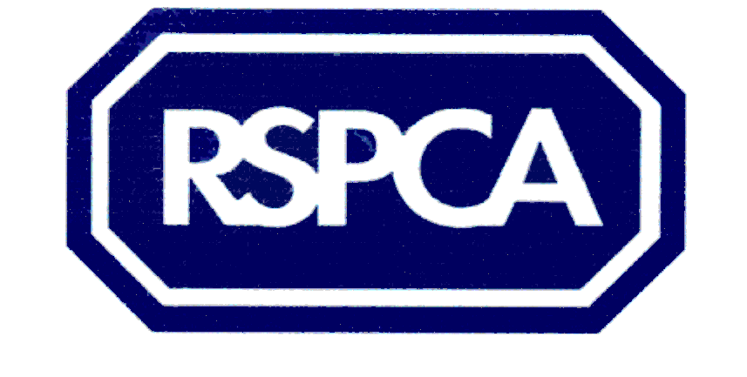
Harrogate & District Branch
Assisted neutering scheme application Form

The RSPCA is a charity and does not receive any help from the Government or the local authority. All the money we spend has to be raised by hard working volunteers, who give their time to fundraise to help local animals.

Please provide the information requested below.

Your name: (IN CAPITALS) …………………………………………………………………

Your address: (IN CAPITALS) …………………………………………………………….
…………………………………………………………………………………………………

Postcode:………………………………… Tel no: …………………………………………..

Which benefits are you in receipt of?

………………………………………………………………………………………………….
PLEASE ATTACH PROOF OF BENEFITS RECEIVED, VOUCHERS WILL NOT BE GIVEN WITHOUT PROOF

Animal's details:
Type (i.e. cat/ breed, size): …………………………………………………………………………………………………..Age: ……………………….. ……………...Sex: ……………………………………………
Colour/markings: ………………………………………………………………………

AGREEMENT
I agree for my animal to be neutered by a nominated veterinary surgeon. Given that the anaesthetic and surgical procedures involve some risk I accept that neither the RSPCA, the RSPCA Harrogate & District Branch or their nominated veterinary surgeons shall be liable for any problems that may occur.

Signed________________________________Dated______________________

Please post the signed, completed form to
Jill Johnson, RSPCA Harrogate & District PO Box 608 Harrogate HG1 9EY
Tel: 01423 886249

Registered charity no: 232219

