

Harrogate & District Newsletter- April 05
Branch Administrator – Jill Johnson
Tel: 01423 886249
Website: www.rspcaharrogate.org.uk

Reg charity no 232219

Hello and Welcome to our 2nd newletter of 2005.
We have got off to a very positive start for 2005 with lots of fundraising events in the diary. Thank you to everyone who is helping to raise Branch funds and awareness of the Branch profile. All monies raised are spent in the Harrogate & District area on
animal welfare.


HARROGATE & DISTRICT BRANCH
Charity no:232219

SEARCH FOR THE RSPCA DOG OF THE YEAR COMES TO

KNARESBOROUGH

The competition for all aspiring rescue dog megastars, large and small will be converging on Knaresborough Pet Day on Monday 2nd May to compete in their local heat of the national event to find the RSPCA Dog of the Year.

The Pet Day takes place at Knaresborough House in Knaresborough. The day’s action starts at 12.00pm but entries will be taken from 11.30am.

There will other dog classes which will include a Novelty Dog Show.

The RSPCA Dog of the Year class is only open to rescue dogs.

Entry fee is £1.00 per dog on the day

Harrogate & District Website.
The Branch website is now up and fully running. Check out www.rspcaharrogate.org.uk if you have access to a computer. Features include animals for re-homing, fundraising events, lottery results plus much more. If there is anything you would like to see included on the website please let me know. As the Branch profile grows we will include further features.
The website will be updated on a regular basis.

Pets Photographic Competition
The pets photo competition runs from February through to 27th May 2005. Entries cost £1 to enter. All entries will be on display in Harrogate library between 6th June and 17th June 2005. The competition judge will be Phil Willis MP and the top three entries will be featured on a Branch card which will be available for purchase from end of July. If you know of anywhere you could display posters or give out entry forms please let me know. As always we need maximum coverage. Entry forms are downloadable from the website.

Friends Meeting on February 17th.
Thank you to everyone who came along to the meeting, we had a really good turn out. Its lovely to hear everyone’s ideas and get to meet socially as well as plan the Branch fundraising programme. Most people felt having regular meetings was a good idea, so we have decided to hold them every two months.
The next one will be held on Tuesday 12th April @ 7.30 @ The meeting room in The Kestral on Wetherby Road Harrogate.
Please do come along and support the Branch, everyone is welcome, if you have not come along before let me know you are coming and I will make sure you receive a warm welcome.

Animal News
We have had a number of animals brought in that are now up for re-homing. Two lovely white rabbits were brought in by an Animal Collection Officer recently. They had only been with us a couple of days and the female produced three babies. Daddy rabbit has now been neutered and is looking for a new home asap. The baby bunnies are now looking for new homes and will be available from 12th April. Mother rabbit will be neutered and will be up for adoption also from 12th April.

We have five cats that are currently looking for new homes.

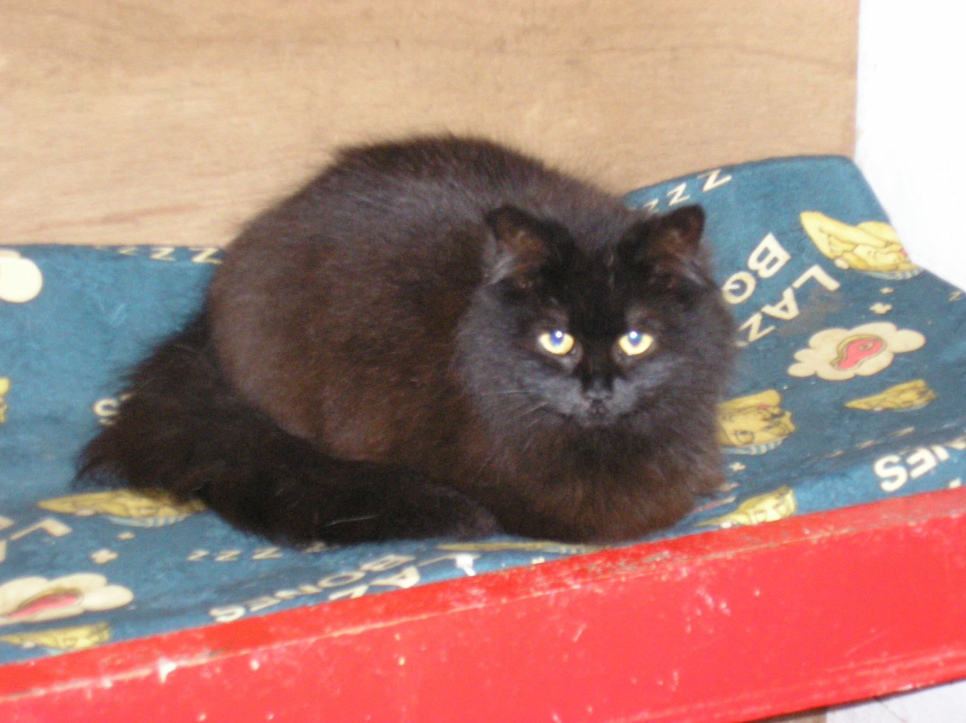
Black neutered female, lovely personality

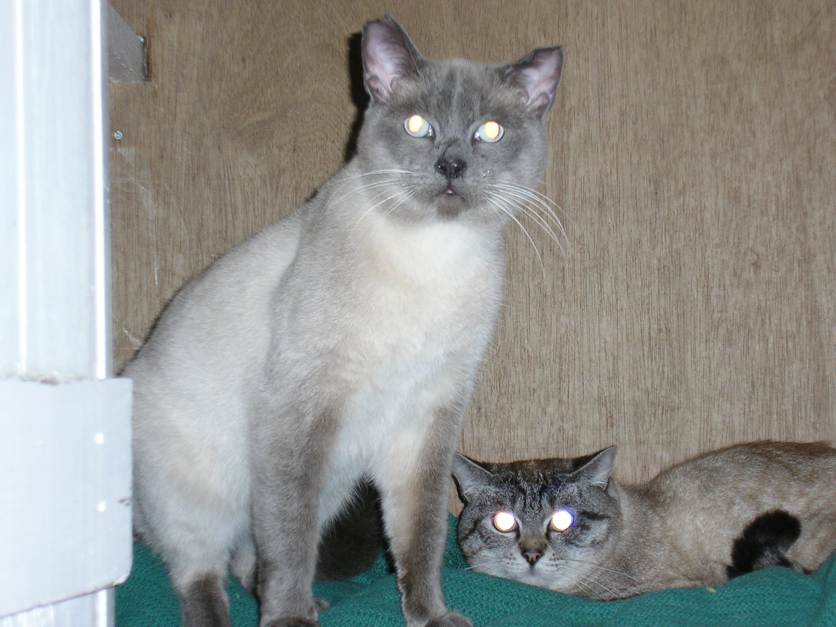
Two males, one is a blue point and the other a seal point tabby. Both neutered, vaccinated, and microchipped. Looking for a home together or individual homes asap.

In addition to the cats shown above we have an older very friendly female who just wants someone to love her. Also, a grey neutered female who is quite timid but would thrive as an only cat in a home with no other pets and no children.
Update
In our last newsletter a lovely caramel rabbit had been found wandering (hopping) around Debenhams carpark, I am now able to report he has since gone to a new home in Harrogate.
Harrogate Town Football Club
On Saturday March 19th three of our younger Branch supporters were presented with three signed footballs at Harrogate Town. The balls will be raffled off to raise funds for the Branch in the near future.
Many thanks to Harrogate Town for supplying the tickets for entry and donating the footballs.



Information session for potential trustees of the Branch.
The session was held on 21st March, unfortunately we had a disappointing turn out on the night. However. on the bright side we do have some interested parties and the Branch will continue to work towards reverting from council trusteeship to having its own group of local trustees in the near future.
If you are interested and would like to meet for an informal chat about what is involved please do not hestitate to contact me.

Knaresborough Pet Day
Monday May 2nd 2005
Plans are well under way for Knaresborough Pet Day.
The Branch has a number of things happening at the Pet Day. We will be holding a heat for ‘Rescue Dog of the Year’. There will be a number of stalls including the sale of RSPCA logo goods and Paws Badges, Hedgehog Game, Beat the goalie, Number of dog biscuits in a jar, Jam Jar Game, Harrogate Town Football raffle, plus we will be offering microchipping on the day, as well as having a Branch information stand. If you think you could help in any way please let me know or come along to the next Friends meeting in April.
We still need volunteers to help and make this day a big success.

Waifs & Strays Lottery
February Winners
1st Prize – £50 - Number 13 – Bryan Robinson
2nd Prize – £20 - Number 7 – Jane Teale

March is mega month for the lottery with the cash prizes going up to £100 and £40, who will be our March winners!
We really need more people to join the lottery to raise more funds to benefit the Branch. For £4 per month not only does local animal welfare benefit, but you stand to win a cash prize. If you would like to join then please get in touch for an entry form or you can download one from the Branch website. www.rspcaharrogate.org.uk

Nidderdale Charity Walk –Sunday 8th May
The Nidderdale Charity Walk is run by The Rotary Club of Harrogate. Unlike some other walks, all sponsorship monies raised by entrants are for their own Charities. There are three routes to choose from ranging from 7 miles to 22 miles. If you would like to take part then and raise money for the Branch please contact Brian Rushton on 01423 885493 for an entry form.
I will be taking part and I am planning to do the 15 mile route, so if you would like to sponsor me then please get in touch.
It would be great if there was a few of us to represent the Harrogate & District Branch on the day!!! Let me know if you are interested in taking part.

Fundraising
Many thanks to our volunteers from Wetherby and surrounding area for raising £271.00 when they held a coffee morning at Collingham Village Hall recently.
Thank you to everyone who also participates in fundraising in any way without your support the Branch would not be able to continue to help animal welfare in the Harrogate District. If you need my help or advice in any way please don’t hesitate to contact me.

Diary Dates in 2005
Pets Photographic Competition – Feb 14th – May 27th

Friends Meeting – April 12th @ 7.30pm The Kestrel Wetherby Road Harrogate

RSPCA Week – 28th April Morrisons Wetherby Collection

Knaresborough Pet Day – Monday 2nd May

Nidderdale Charity Walk – Sunday 8th May

Church Fete @ Wetherby – Saturday 11th June

Harrogate Flag Day – Saturday 25th June

Wetherby Pram Race & Lions Day – Sunday 3rd July

Ripon Flag Day/Wetherby Flag Days – Saturday 16th July

Knaresborough Flag Day – Saturday 6th August

August – Microchipping Campaign

Sainsburys Collection Day – Saturday 3rd September

Jumble Sale Hampsthwaite Memorial Hall – Saturday 10th September

Asda Collection Day – Saturday 29th October

Quiz Night Wetherby – Saturday 10th December

December – Xmas Fayre

We need volunteers to help with most of the above events if you can help in anyway please let me know. All help is appreciated.

