

Harrogate & District Branch Newsletter
Registered Charity No. 232219

April 2012
www.rspcaharrogate.org.uk

BRANCH CONTACT DETAILS

Branch Manager – Jill Johnson
PO Box 608, Harrogate, HG1 9EY
01423 886249
email:rspca.harrogate.org.uk

Community Fundraiser – Charlie Davison
PO Box 182, Knaresborough, HG5 5BB
07817 344139
email:fundraising@rspcaharrogate.org.uk

To report an animal in distress or an emergency,
please call the RSPCA 24-hour Cruelty and Advice line
0300 1234 999

Stray Dogs
Neither the RSPCA nor the police can deal with stray dogs, which are the responsibility of the Dog Warden Service. The numbers to ring about strays are now:

If you find a dog
Please ring 01423 556633 or 01423 500600 during office hours
or 07525 988048 for the Out of hours stray dog reception.

If you have lost a dog
Please ring 01423 556633 or 01423 500600 during office hours or
07525 988048 for the Out of hours stray dog reception.

BRANCH & ANIMAL UPDATES
Hello and welcome to our Spring newsletter. There are lots of things happening at the Branch at the moment. Many of you will know Charlie who has been organising various successful events for quite some time. Charlie has taken over fundraising completely now and has been very busy organising events for the branch in 2012 so check out our events page for dates and details. As always any help you can offer is greatly appreciated as are the donation of raffle prizes.
We are hoping to have a brand new website up and running over the next few months which will be more user friendly and allow us to take donations online.

Lottery Winners
December 2011
1st – Jackie Paradis (2)
2^{nd-} Daphne Barrett (34)

January 2012
1st – Ruth Greenwood (41)
2nd – Carol Dale (59)

To join our exclusive ‘Waifs & Strays’ Lottery 100 Club, all you have to do is pay a £1 membership fee and complete the attached form agreeing to pay £4 per month by standing order. This will enter you in our very own ‘Waifs & Strays’ Lottery.

Each month for 10 months one lucky member of the ‘Waifs & Strays’ Lottery will win £50 and a second member will win £20. In addition twice a year, in March and September there will be a Mega Prize Draw where the first prize will increase to £100 and the second prize to £40. The draw will take place on the last day of every month.

You stand a very good chance of winning any one of the 24 prizes, and you will be helping the local branch of the RSPCA at the same time.

Animal Updates
Re-homing got off to a very slow start this year but I am pleased to report that we seem to have turned a corner and we are getting lots of enquiries for cats and kittens. Two of our long-term stay cats, Toby and Topsy, have recently been re-homed and we are absolutely delighted as they were lovely cats. Toby’s new owners contacted us just 24 hours after he had been re-homed to say he had escaped out of an upstairs window. They were distraught as were we! Several of us went looking for him and posters went up, however we got a call 48 hours later to say he had never left the house, he had managed to squeeze himself into a very small space. The latest news is that he is very happy and settled into his new home.

Needing Homes
Scraggles is a black & white short haired neutered male aged about 3. He is very friendly and is looking for a loving home. Scraggles came to us with a flea allergy that had not been treated and has lost some of his fur. He is a really lovely boy and deserves a special home.

George is a lovely black and white neutered male aged about 1 year old. He is very friendly and will make a lovely pet. George loves being fussed over and is very playful.

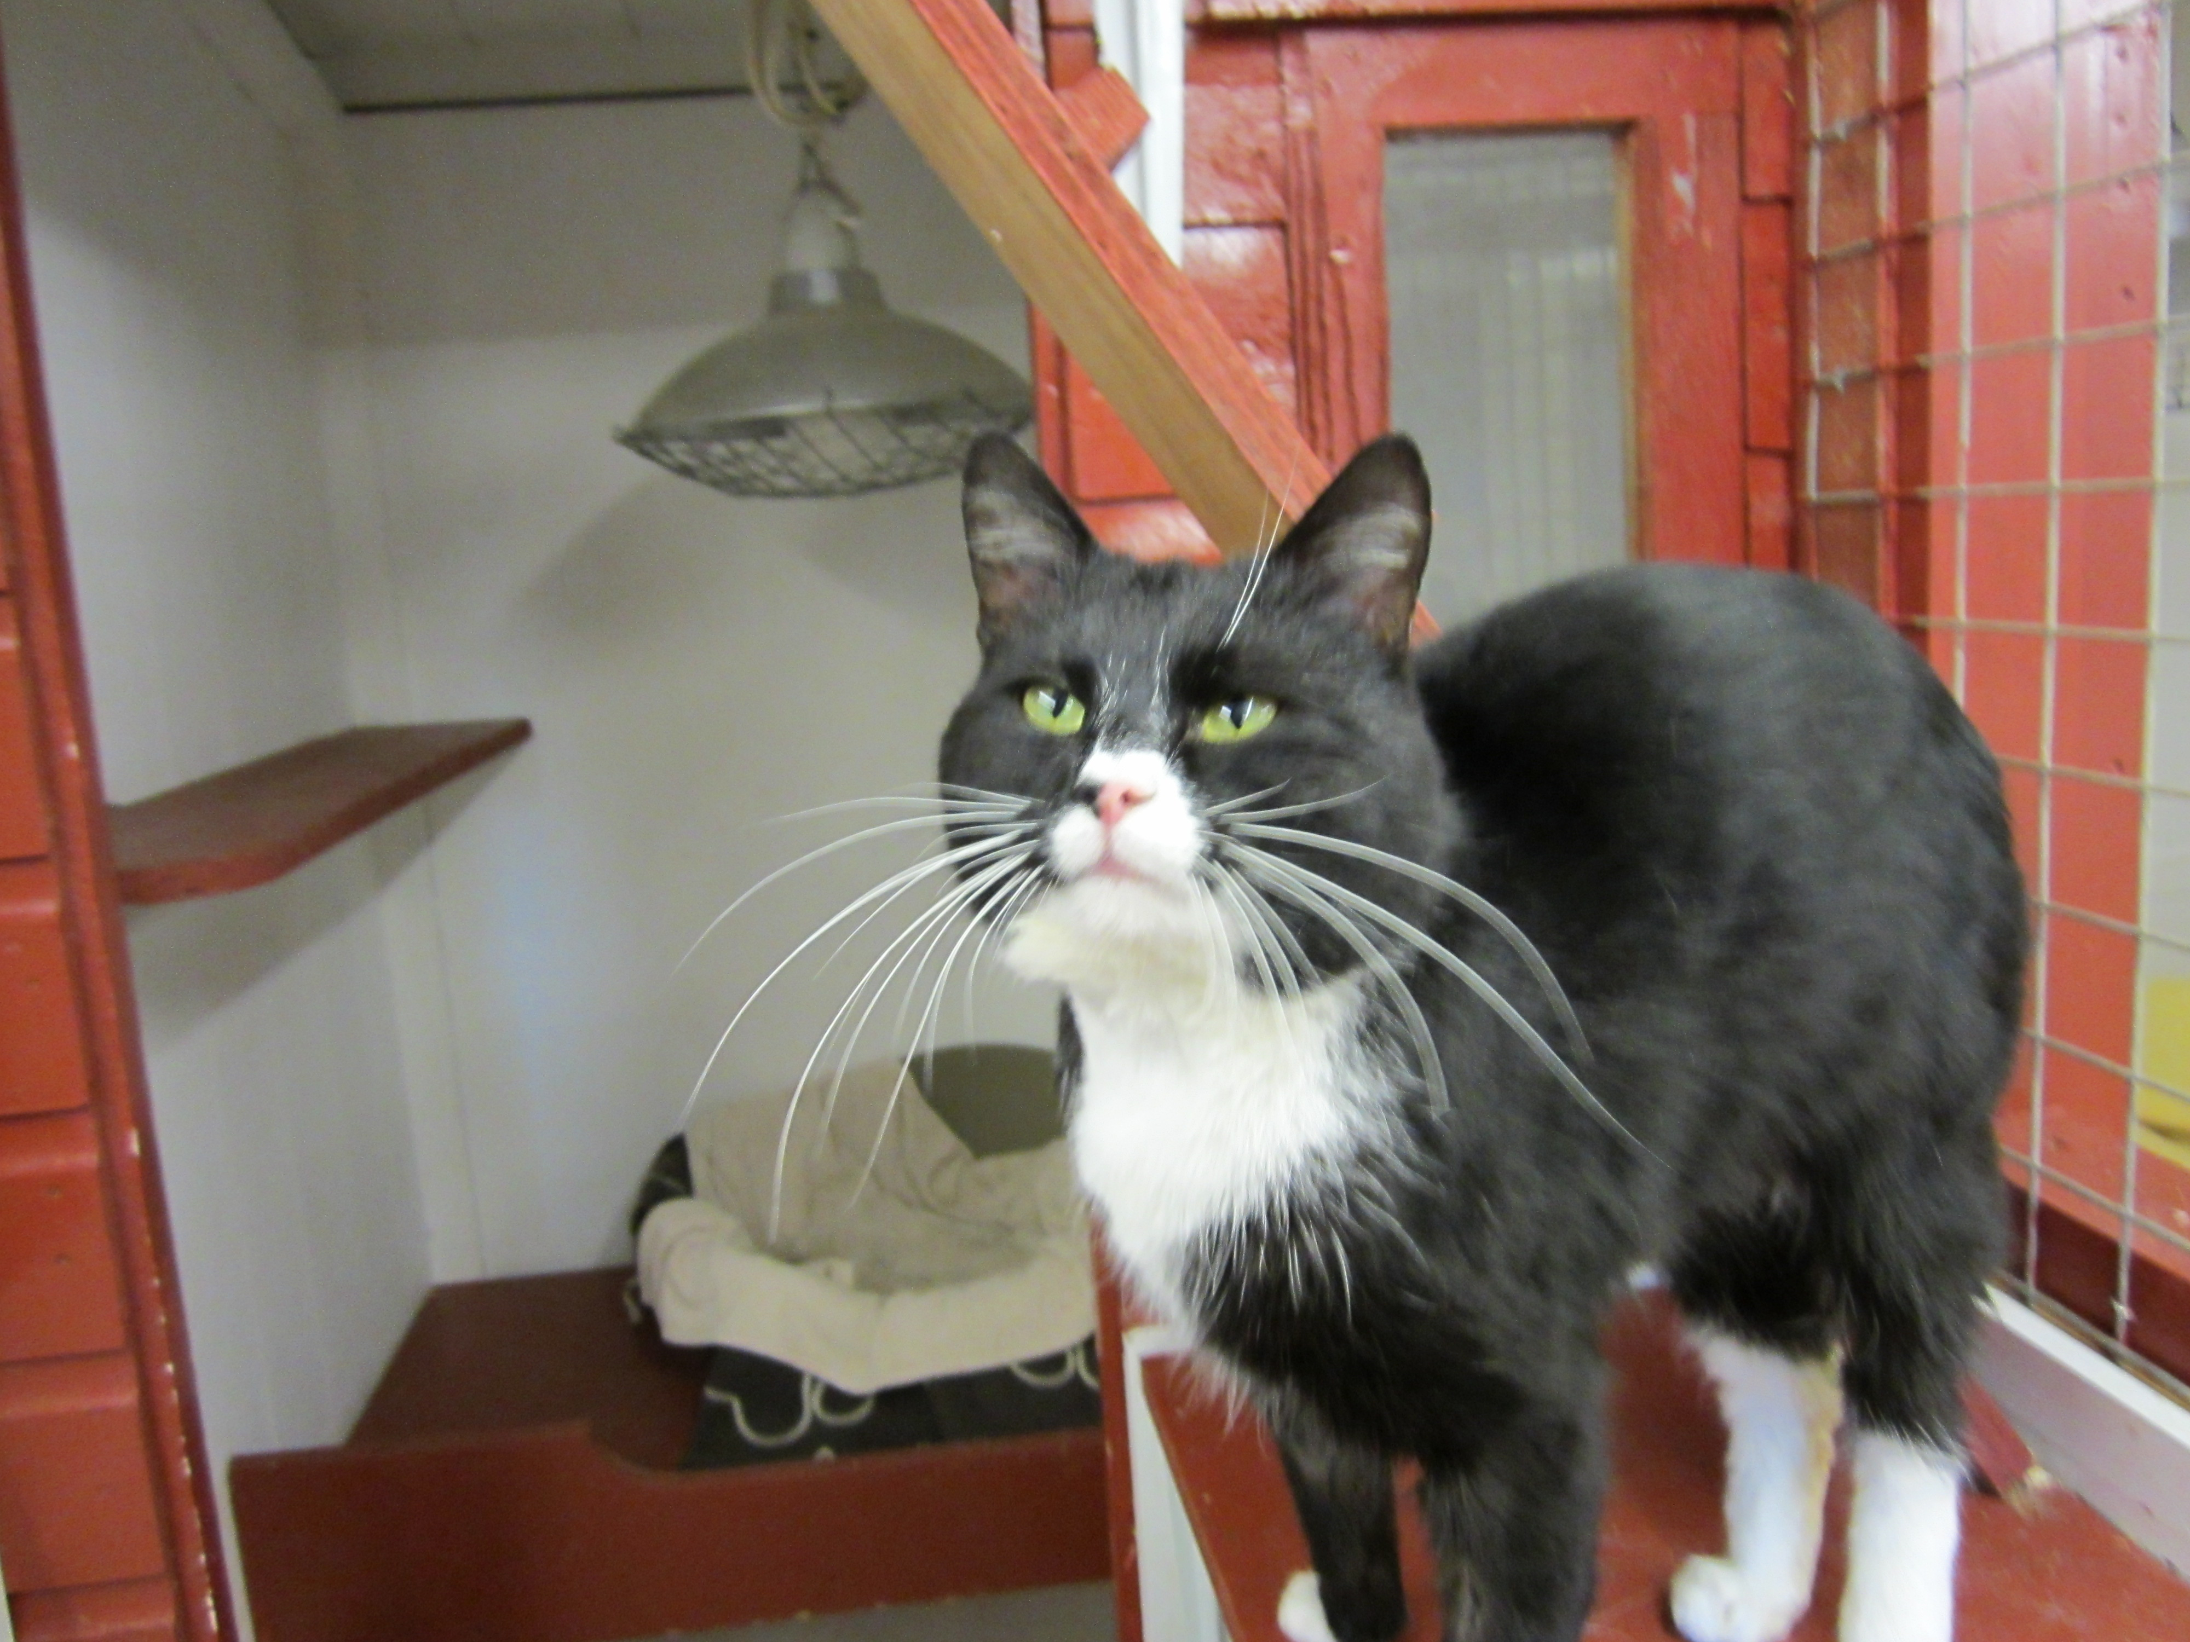

Free Cat Neutering Vouchers
For a limited time only the Branch is offering free cat neutering vouchers to be used at Vets4Pets Harrogate. The initiative is only open to those on certain income based benefits. The vouchers are not transferable. Contact the Branch for further details.

Volunteers
The RSPCA Harrogate & District Branch relies on a small but dedicated team of volunteers to carry out vital animal welfare work and raise much needed Wefunds to help animals in the Harrogate, Wetherby, Ripon and Knaresborough districts.

Come along to one of our Volunteer Evenings for an informal chat and find out how you can help.

For further information contact Charlie on 07817 344139 or email fundraising@rspcaharrogate.org.uk

The RSPCA is committed to equal opportunities and actively encourages diversity in its volunteering roles.

Events Diary 2012
Apart from the events listed on the next page, we will also be having a couple of car boot sales during the year and also a Jumble Sale at the end of the year. Dates to be confirmed but donations of things to sell will be appreciated.

Events Diary 2012

April
Monday 16^{th-} Volunteer Evening @ The Kestrel Wetherby Road Harrogate 7.30pm – 9pm
Friday 27^{th-} Golf Day. Pannal Golf Club.

May
Wednesday 9th- Quiz and Curry Night.
The Smiths Arms, Beckwithshaw, at 7:30pm.
Tickets are £5 and include the quiz and a curry.

June
Saturday 23rd – Bupa Southlands Dog Show & Fun Afternoon 2pm –4pm
Friday 29th – Collection @ Asda Harrogate

July
Sunday 1st – Summer Fair @ Brearton Village Hall
Friday 20th – Closing date for picture competition
Saturday 28th- Birstwith Show & RSPCA Dog Show

August
Saturday 4th- Collection @ Morrison’s @ Boroughbridge
Friday 17th – Collection @ Morrison’s @ Ripon

September
Friday 14th – Collection @ Sainsbury’s Harrogate

October
Saturday 20th- Collection @ Booth’s Ripon

December
Christmas Party!!!! Date and venue to be confirmed – best party frocks at the ready

FACEBOOK

We now have our own Facebook page!!

Come and join us on Facebook and receive regular updates on events and things that are happening in the area

Just type in Harrogate District RSPCA

FRIENDS MEETING

Back by popular demand…

Please come and join us at the friends meeting on Tuesday 15th May 2012

Kestrel, Wetherby Road, Harrogate
7.30pm

OVER TO YOU

We would love to include your stories and experiences in our newsletter.

Have you adopted a rescue animal?

Have you organised and event and would like to tell us about it?

Do you have a pet with attitude who would love to have their photo in print?

Please send your contributions via email or by post to have them included in the next edition of the Branch newsletter.

