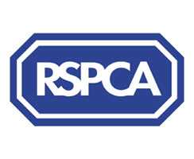

Harrogate & District Newsletter- Autumn 05
Branch Administrator – Jill Johnson
Tel: 01423 886249
Website: www.rspcaharrogate.org.uk

Reg charity no 232219

Hello and welcome to our autumn newsletter. We have had a very busy summer with lots of events and fundraising.

Birstwith Show
The RSPCA dog show was a major attraction at the show, which had very few other stands and animal charities present. The branch made £325 from the dog show, stalls and raffle. I think next year we should look at expanding on what we do on the day and make the most of the opportunity

Starbeck Gala
After a slow start to the morning lots of people turned up to support our stalls. As always the dog show proved to be very popular with lots of entries.
We had a lady from Scarborough who came along and did pet sketches and donated all monies to the branch. The sketches were so popular we have booked her to come along to Knaresborough Pet Day next year. Over £196 was raised.

Hampsthwaite Jumble Sale
Never having been involved in a jumble sale, it turned out to be a real experience………I could not believe the amount of jumble we ended up with or the queues of people waiting to come in. It certainly was very worthwhile as we made £370.

Sainsburys Collection
We had a really good day at Sainsbury’s with £407 being taken.

Nidderdale Charity Walk
Many thanks to Joe Margham who donated £44 in sponsor money to the Branch. It is very much appreciated.

I would just like to say a huge Thank You to everyone who helps at events and collections. My role is made so much easier having a great group of volunteers who support the Branch in its vital work to help animal welfare.

Animal News
We have had a number of animals come into the Branch over the past few weeks, including quite a few kittens. I would just like to say a special Thank You to Jenny from Knaresborough who is a new fosterer for the Branch. She has very kindly looked after a mother cat and five kittens. All are reserved and looking forward to going to new homes in the next week or so.
I’m also pleased to report Smudge and her kittens featured in the last newsletter have been re-homed.
Also, Earl who had been with us some time has gone to a lovely new home.
We do have some lovely cats who are in desperate need of a new home.

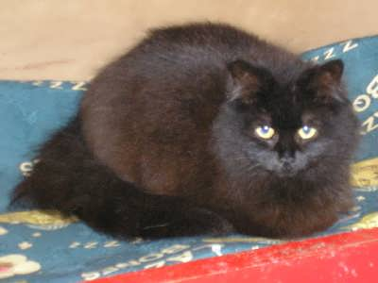

This is Smokie, who has been returned to us due to no fault of his own. He is a lovely long haired dark chocolate brown cat who is about three years old. He has a lovely personality and has been with us for several weeks. If you can offer Smokie a new home please contact the branch.

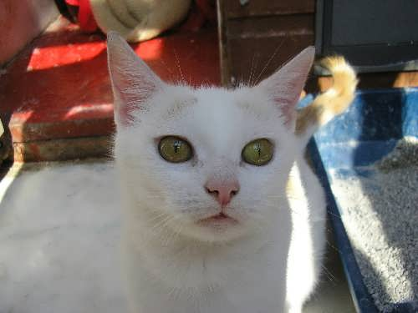

Jewel is a beautiful young cat who is extremely affectionate and would make the most loving pet. (Picture does not do her justice). She came to us several weeks ago with her kitten and is now ready to be re-homed.

Urgent appeal
As many of you are aware the Animal Welfare Bill will be coming before Parliament over the next few weeks. The RSPCA wants to see the law changed so that when animals are being neglected their owner has a duty to rectify the problem. The new act would help to ensure that owners recognise the gravity of their responsibility and make it an offence not to provide the basic needs for their pet.
You can support the RSPCA by writing to your local MP and asking them to vote for the new legislation.
The address to write to is Mr P Willis MP, Ashdown House, 75 Station Parade, Harrogate HG2 8LU.

Waifs & Strays Lottery
July Prize Winners
1st prize – £50 – Jackie Paradis (2)
2nd prize - £20 – Julia Moore (22)

August Prize Winners
1st prize – £50 – Craig Johnson (17)
2nd prize - £20 – Mrs B Bradley (36)

The lottery has raised over £400 for the Branch since it started in January, as well as cash prizes for winners. We do still need more people to join so if you are interested then please get in touch for an application form.

RSPCA & Dogs Trust Free Neutering Campaign
We are still running the campaign and will do so until the vouchers run out. If you know of someone who may be eligible or may have a dog at risk please get them to contact the Branch.

Branch Shop
As many of you are aware we are hoping to open a Branch shop in the area in the near future. If you know or spot any premises that may be suitable please can you let us know. We are registered with a number of letting agents but any help with possible premises would be appreciated.
Areas we will be considering are Harrogate, Knaresborough, Ripon and Wetherby.

Microchipping Campaign
The microchipping campaign was a big success with 165 animals being microchipped in August and raising £900 for animal welfare. A big Thank You to all the Vets who participated in the campaign. They are:
Vets4Pets - Harrogate
Bishopton Veterinary Group - Ripon
Rae Bean & Partners - Boroughbridge
Hutchinson Dunlop & Baird - Wetherby
Forest House – Knaresborough
Ashleigh Veterinary Clinic - Knaresborough

Mutt Strutt – Sunday 2nd October

Please come along and support our first ever Mutt Strutt around Ripley Castle on Sunday 2nd October at 11.00am.
The route is approximately 3 miles and is very easy going. Each participant will receive a special edition Butchers rubber dog ring.

There are prizes on offer for the person who raises the most sponsorship, the dog with the waggiest tail, the youngest human member who completes the walk, plus other categories.

Refreshments will be available at the start and end of the walk.

Entry is £5 per family or by sponsorship form.
Registration forms are available by contacting the branch, and entries are now being taken.

If you can help on the day with registration or refreshments please let me know.

Rescue Dog of the Year

Many of you will remember we ran a heat of the Dog of the Year at Knaresborough Pet Day in May. The winning dog was Fudge (in the centre of the photo) and his owners had to submit Fudges story to HQ for him to go to the next round. This is the story that Fudge’s owner Chris Wall has submitted. It’s a fantastic story with a very happy ending.

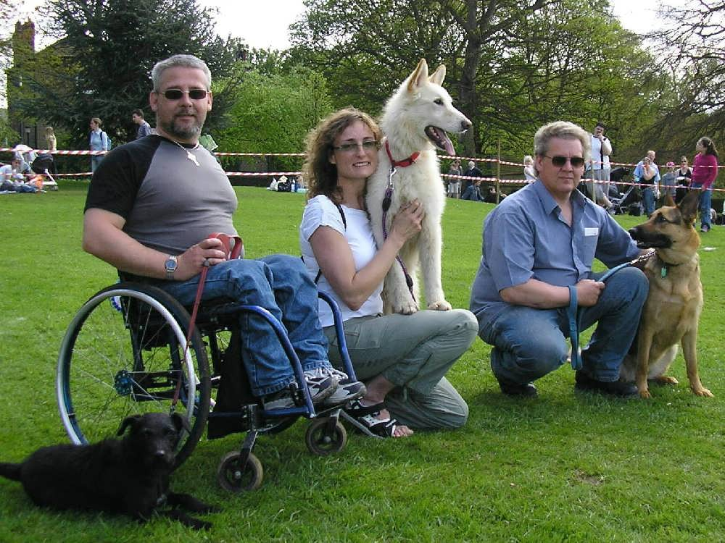

Fudge is a German Shepherd/Husky cross breed, about 6 years old. I met Fudge at Great Ayton RSPCA, North Yorkshire, he was about 8 months old. Fudge had been rescued and was awaiting the results of a court case. He had been the victim of cruelty, tied-up day and night in a back yard and not socialised. Fudge had medical problems with his bones and needed treatment for the next 2 months, we visited him regularly. The first time we took him out, he had some problems, he hated the lead, did not like men or other dogs. The RSPCA needed a foster home for him to give them some information for his portfolio, so we took him home for a trial period. In reality there never really was a trial period, he had bonded with us and was now part of the family.
We have had hard times when it seemed that Fudge would never be confident and relaxed around people (especially adult males) and dogs. We have been to training courses, agility, fly-ball, and numerous dog shows, we have spent hours socialising him. Gradually Fudge has become more confident around people, initially he would try to do hula hoops on the lead, now he walks with grace and pride attracting many admiring glances. The proof is in him qualifying for the final of the Dog of the Year for the first time. Fudge is the most loving and loyal dog, he appreciates the love he has been given by our family. He never tires and is ready to go for a walk within 5 minutes of the last one. The last 12-18 eighteen months Fudge has learnt to wag his tail and now he gets plenty of practice. He is very loyal and never wanders far from us, he always makes a great fuss of his family – even if we have just been out of his sight for 5 minutes. He has grown very handsome – far removed from the “ugly duckling” look and uncoordinated “giraffe-like” walk he had when we first met.
As an athlete Fudge is a gold medalist, he loves to run, jump and play. He is a wonderful dog with his own free spirit, I am honoured that he has chosen to bond with me. I can’t say enough about him, everyday is a challenge, fun and different, a day that is never boring with Fudge.

Chris Wall

Will keep you posted as and when we hear anything from HQ.

Fireworks
As we all know it is coming to the time of year where fireworks become a real problem. One of our volunteers, Audrey has produced a poster highlighting the problems of fireworks and pets. If you would like one let me know and I will put you in touch with Audrey. I will have some with me at the next meeting.

New Inspector

We have a new Inspector Mike Pugh, I have invited him along to the next Friends Meeting.

Diary Dates in 2005

Friends Meeting – Thursday 29th September @ 7.30pm @ The Kestrel Wetherby Road Harrogate.

Mutt Strutt – Sunday 2nd October @ 11.00am @ Ripley Castle field car park

Asda Collection Day – Saturday 29th October

Cat Neutering Campaign - November

December – Xmas Fayre – Town Hall Wetherby 26th November 2005

Friends Meeting – Xmas Meal – Date to be confirmed

Quiz Night Wetherby – Saturday 10th December

Early 2006
Cheese & Wine Evening – Date to be confirmed

Morrisons Boroughbridge Collection – Date to confirmed

We need volunteers to help with most of the above events if you can help in anyway please let me know. All help is appreciated.

We will be planning our fundraising and social calendar for 2006 over the next few weeks. If you have any suggestions for events please let us know.

