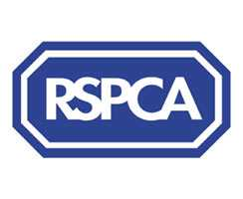

Harrogate & District Newsletter- Dec 06
Branch Administrator – Jill Johnson
Tel: 01423 886249
Website: www.rspcaharrogate.org.uk

Reg charity no 232219

Harrogate Committee
I’m delighted to report that at the AGM on 30th October the Branch reverted from council trusteeship back into local trusteeship. We now have seven members forming the committee. The AGM was extremely well supported with members and volunteers, I don’t think we could fit another person in the room. Thank you to all that came along and supported, it really is appreciated. Below is a brief introduction to each of our committee members. I’m sure over the coming months both members and volunteers will get to meet each of the committee members and work together to promote animal welfare and the work of the branch.

Chairperson - Shelley Devonshire

“I was elected Chair of the new Committee on 30 October 2006. Recently retired from involvement in the family business in Harrogate, I previously spent 18 years in the voluntary sector with the Royal National Institute for the Blind as Regional Co-ordinator for the North of England and Head of their Care Support Services. My work involved improving care standards for visually impaired people across the country by offering consultancy and training, and by providing input to the recent Royal Commission on services for older people.”

Treasurer - Roger Wilkins
Roger has had a career in central government working in various departments including Department of Environment, Cabinet Office and HM Treasury. He has considerable experience of project and financial management and is a member of the Chartered Institute of Purchasing and Supply.
Roger is married with one son. His interests include sports and walking. He is also a volunteer worker for the Prince’s Trust.
Secretary – Philip Warrington
“I live in Knaresborough and other than a brief spell abroad have lived in the area for the past 20 years.
I am 50 years old and most of my career has been in the retail industry, and I am now hoping to be able to help the RSPCA find and operate a shop within the local area.
My parents introduced me to dogs as a child and were very insistent that the family pet was properly looked after and looking back I like to think that we did a pretty good job with all 4 of our pets.
It was only in later life when I met my wife and her pet cat Cleo that I was first introduced to cats. I had never really taken to cats and aged, grumpy old Cleo just reinforced my opinion! My wife told me not to judge all cats by Cleo and very quickly showed me that cats can also make perfect pets just like dogs.
Shortly after we married we applied to the CPL and rescued 2 fabulous moggies who are now approaching 18 years of age and have given us endless pleasure and fun. Indeed one of them is watching me write this with her bum up against the radiator.
With this in mind I decided maybe I could help other homeless and unfortunate animals.
My hobbies are swimming and dales walking.”

Lynda Wright

“Hi, my name is Lynda Wright, I live in Harrogate and work in Leeds where I am employed as a Legal Secretary.

I have been involved with the Dogs Trust and initially started out as a ‘dog walker’ (having two dogs of my own, I decided that if I could walk 2 dogs, then I could have a go at walking 6!). I then became involved with fundraising and elected onto the Committee. I remained with the Dogs Trust for some 10 years before relocating to Harrogate.

I am interested in animal welfare and environmental issues. My hobbies include attending the gym, cycling, dancing, and walking. I am very excited about the future for the RSPCA Harrogate Branch and looking forward to meeting members and volunteers”

Lois Thorpe
“I've lived in Harrogate for nearly five years and have three cats.
Animal welfare has always been an important issue for me and I'm looking
forward to being part of the committee and helping the Harrogate RSPCA
branch to promote good animal care practice and prevent cruelty in the
area."
Lyn Jones

“Hi, I’m Lyn Jones, a newly appointed Trustee. I have resided in Harrogate for over 20 years but originate from “Robin Hood Country” Nottingham (don’t think I am related to Friar Tuck! But do share a sweet tooth!)
I am divorced with a daughter and currently have two lovely Grandchildren aged 1 and 5. They are very active individuals and consequently keep me busy. My mum, who reached the ripe old age of 92 lives in a local nursing home and I like to visit her every other day. When I am not child sitting, mum visiting or dog walking, I work freelance as a stress counsellor. I started counselling over 10 years ago and worked for “Cruse” (bereavement counselling) for several years before branching out into other spheres of counselling.
My constant passion however, throughout my life has been a love of animals, especially dogs. Consequently, I feel privileged to have been elected and feel confident that the new local Trusteeship will go from strength to strength in the years to come.
Sally Robinson
“My name is Sally Robinson and I live in Cawood, near Selby, with my husband Andrew and our two rescue rabbits, Clover and Bugsy. I work as a social worker in York and am actively involved in a number of charities, raising awareness and fundraising. When I manage to catch a spare moment, I enjoy walking and going to the theatre. I’m looking forward to being a Trustee for the RSPCA Harrogate Branch and in particular, promoting the welfare rights of smaller animals.”

Fundraising
We have had a really good year for fundraising with lots of different events and locations. I just want to say a huge Thank You for everyone who has helped in anyway with fundraising. Without your support we could not carry out the work we do for animal welfare.
Next years events diary is already looking good, we do have a few dates to confirm and are looking at holding some new events later in 2007.
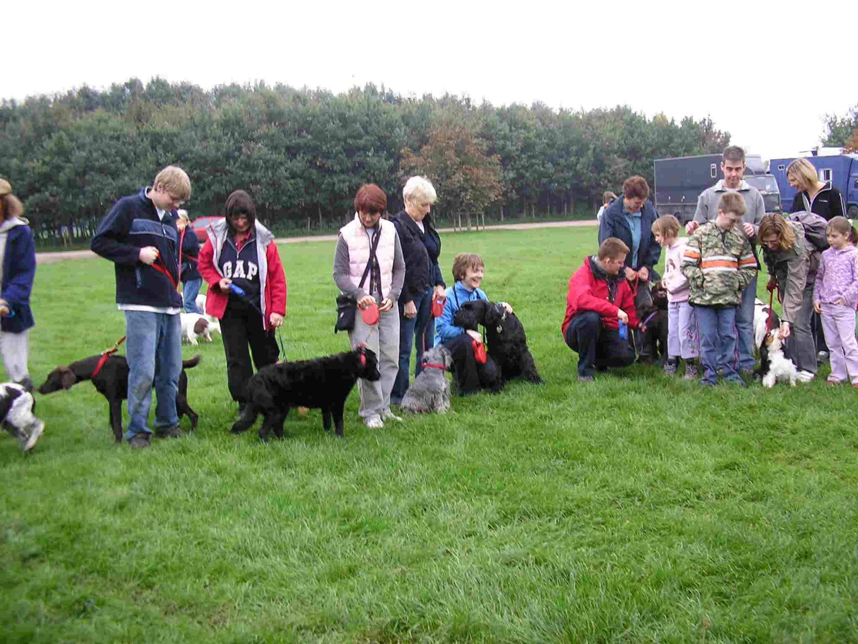

Recent events – The annual Mutt Strutt was again a big success with over 20 dogs and lots of humans taking part. We raised over £160 which was fantastic and had many requests for it to be held again next year. A big Thank You to Suzanne and Lucy Thorp who supplied the catering on the day and donated some of their profits.
Jumble Sale at Hampsthwaite raised over £350, Thank you to everyone who helped and Carol Packer for organising it.
Wetherby Xmas Fayre also raised £340, Thank you to Pat Jenkins and all the volunteers in Wetherby.
Morrisons @ Starbeck, raised £260 again thank you to all who gave up their time for however long it really is appreciated.

Animals

Re-homing update
We have had a very busy couple of months with re-homing I am pleased to report that all the animals featured in our last newsletter have been re-homed, October and November saw lots of late kittens coming to us, they have all found new loving homes.
As always we have a number of adult cats who need new families to give them permanent loving homes.

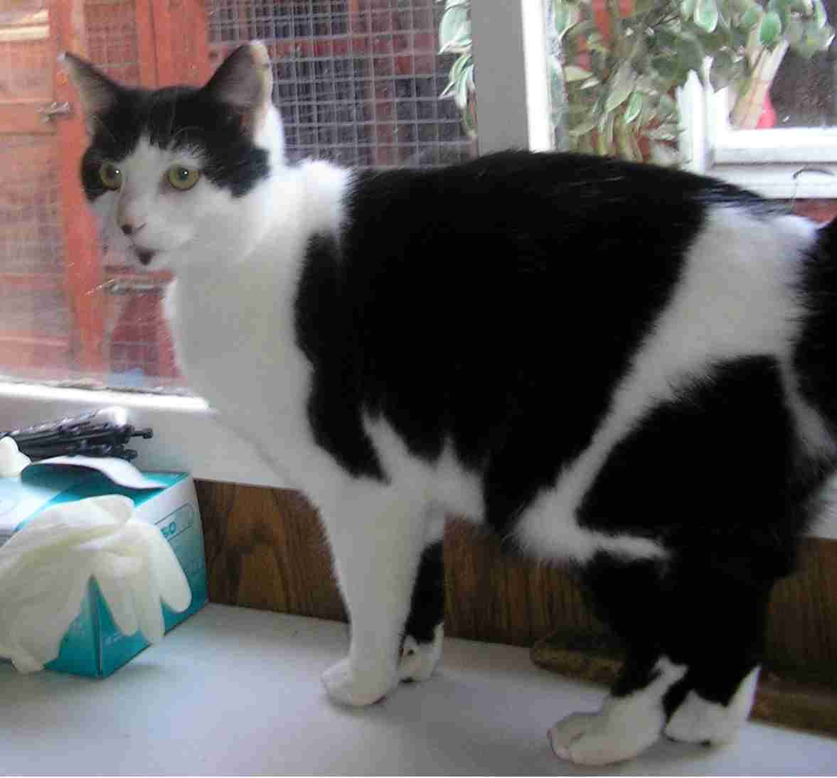

Panda – is a lovely neutered black and white cat. He is loving and affectionate and would love a new home.

Tulip – is a young neutered female cat who has recently had a litter of kittens. She is black and ginger and is now ready to go to a new loving home.

Please look at our website or call the branch for updated details on animals that need re-homing.

Dog/Cat Neutering Campaign

We will be running a concentrated dog/cat neutering campaign throughout February 2007. People on income based benefits will be eligible for full cost neutering of dogs and cats throughout this period. The campaigns have been a huge success in the past and have undoutbly resulted in many animals being neutered thus a decrease in the number of puppies and kittens being produced. We are hoping this will run through to the community action week and there will be a big take up within the local community.

Lottery Winners
August 06
1st – Shirley Neal (3)
2nd - Kirsty Hollingworth (9)
September 06
1^{st -} Daphne Barratt (34)
2^{nd -} Jane Teale (6)
October 06 –
1st - Jane Crawley (29)
2nd - Jean Gregg (24)

If you or anyone you know would like to support the branch lottery then please fill in the enclosed application form. It is a great way of supporting the branch in providing funds for the animals in our care and possibly winning some money in the process.
We do need more lottery members in order to keep the lottery going in 2007.

Thank You
Thank you to Katie Wolstenholme who kindly donated £10 to the branch from a toy stall she had at a recent event.

Community Action Week
As a region we are looking at holding community action weeks in early 2007. The idea behind them is that we organise local events within the community that will promote local animal welfare and responsible pet ownership.
We are looking to hold our action week in March, exact dates and events to be confirmed early 2007.

Microchipping
The Branch microchipping campaign will run throughout September 2007.

Shop Update
We have put looking for a branch shop on temporary hold whilst our new committee has a period of consolidation. Hopefully 2007 will see the Branch with a new shop.

EVENTS 2007

Saturday 20th January Morrisons Collection Ripon COLLECTORS NEEDED PLEASE

Friends Meeting Thursday 25th January @ 7.30pm @ The Kestrel

Dog/Cat Neutering Campaign – February/March

Saturday 31st March Coffee Morning @ Boston Spa

Community Action Week – March

Saturday 28th April Morrisons Collection Wetherby

Monday 7th May – Knaresborough Pet Day

Harrogate Flag Day - June

Birstwith Show Saturday 28th July

Saturday 4th August Morrisons Collection Boroughbridge

Starbeck Gala & Dog Show – August

Morrisons Collection Starbeck – September

Branch Microchipping Campaign – September

Saturday 20th October Sainsbury’s @ Harrogate Collection

Saturday 27th October Morrisons @ Boroughbridge Collection

Mutt Strutt – October

Wetherby Xmas Fayre – November

Jumble Sale - November

