
Harrogate & District Newsletter- February 05
Branch Administrator – Jill Johnson
Tel: 01423 886249
Website: www.rspcaharrogate.org.uk

Reg charity no 232219

Hello
Welcome to our first newsletter of 2005. The newsletters are bi-monthly so I am able to keep you up to date with everything that is happening. We have lots of fundraising events happening in 2005 but if you would like to make any suggestions then please let me know. The Branch has a small but dedicated team of volunteers who carry out animal welfare work and organise fundraising events. However, we are always looking for more volunteers so please contact us if you would like to help.
Remember every penny we raise is spent in the local area on animal welfare and promoting responsible animal welfare.

Sainsbury’s Collection Day
This was postponed due to Sainsbury’s collecting on behalf of the Tsunami Disaster. The re-arranged date is Saturday 3rd September 2005.

Animal Magic Moments
The Branch is running a Pets Photographic Competition February 14th – May 27th 2005.
Each photo costs £1 to enter and the competition is open to anyone as long as the photos entered are taken by an amateur. Multiple photos can be entered but each is subject to a £1 entry fee. After the closing date in May all photographs will be judged by someone completely independent of the RSPCA. The three photos judged to be the best and most original will appear on the front of the Harrogate & District Branch Christmas Card for 2005. The cards will be ready to sell at events and outlets from end of June onwards. The photographs will be on display in Harrogate Library from 6th June- 17th June.
Entry forms will be available from Vets4Pets, Harrogate; Posh Paws, Leeds Road; and myself. If you are able to distribute some entry forms and posters please let me know. Details will also be featured in Harrogate Advertiser.

Home Visitors Course
The Branch ran a home visitors course in January, we now have people who are able to go out and assess homes of potential adopters. We hope to re-run the course again in the summer for anyone who may be interested.

Animal News
The Branch has continued to re-home animals brought into us by the RSPCA Collection Officers and Jackie our local Inspector. We have been fortunate to find some lovely homes for older cats. However, we do currently have a resident who is looking for a new home.

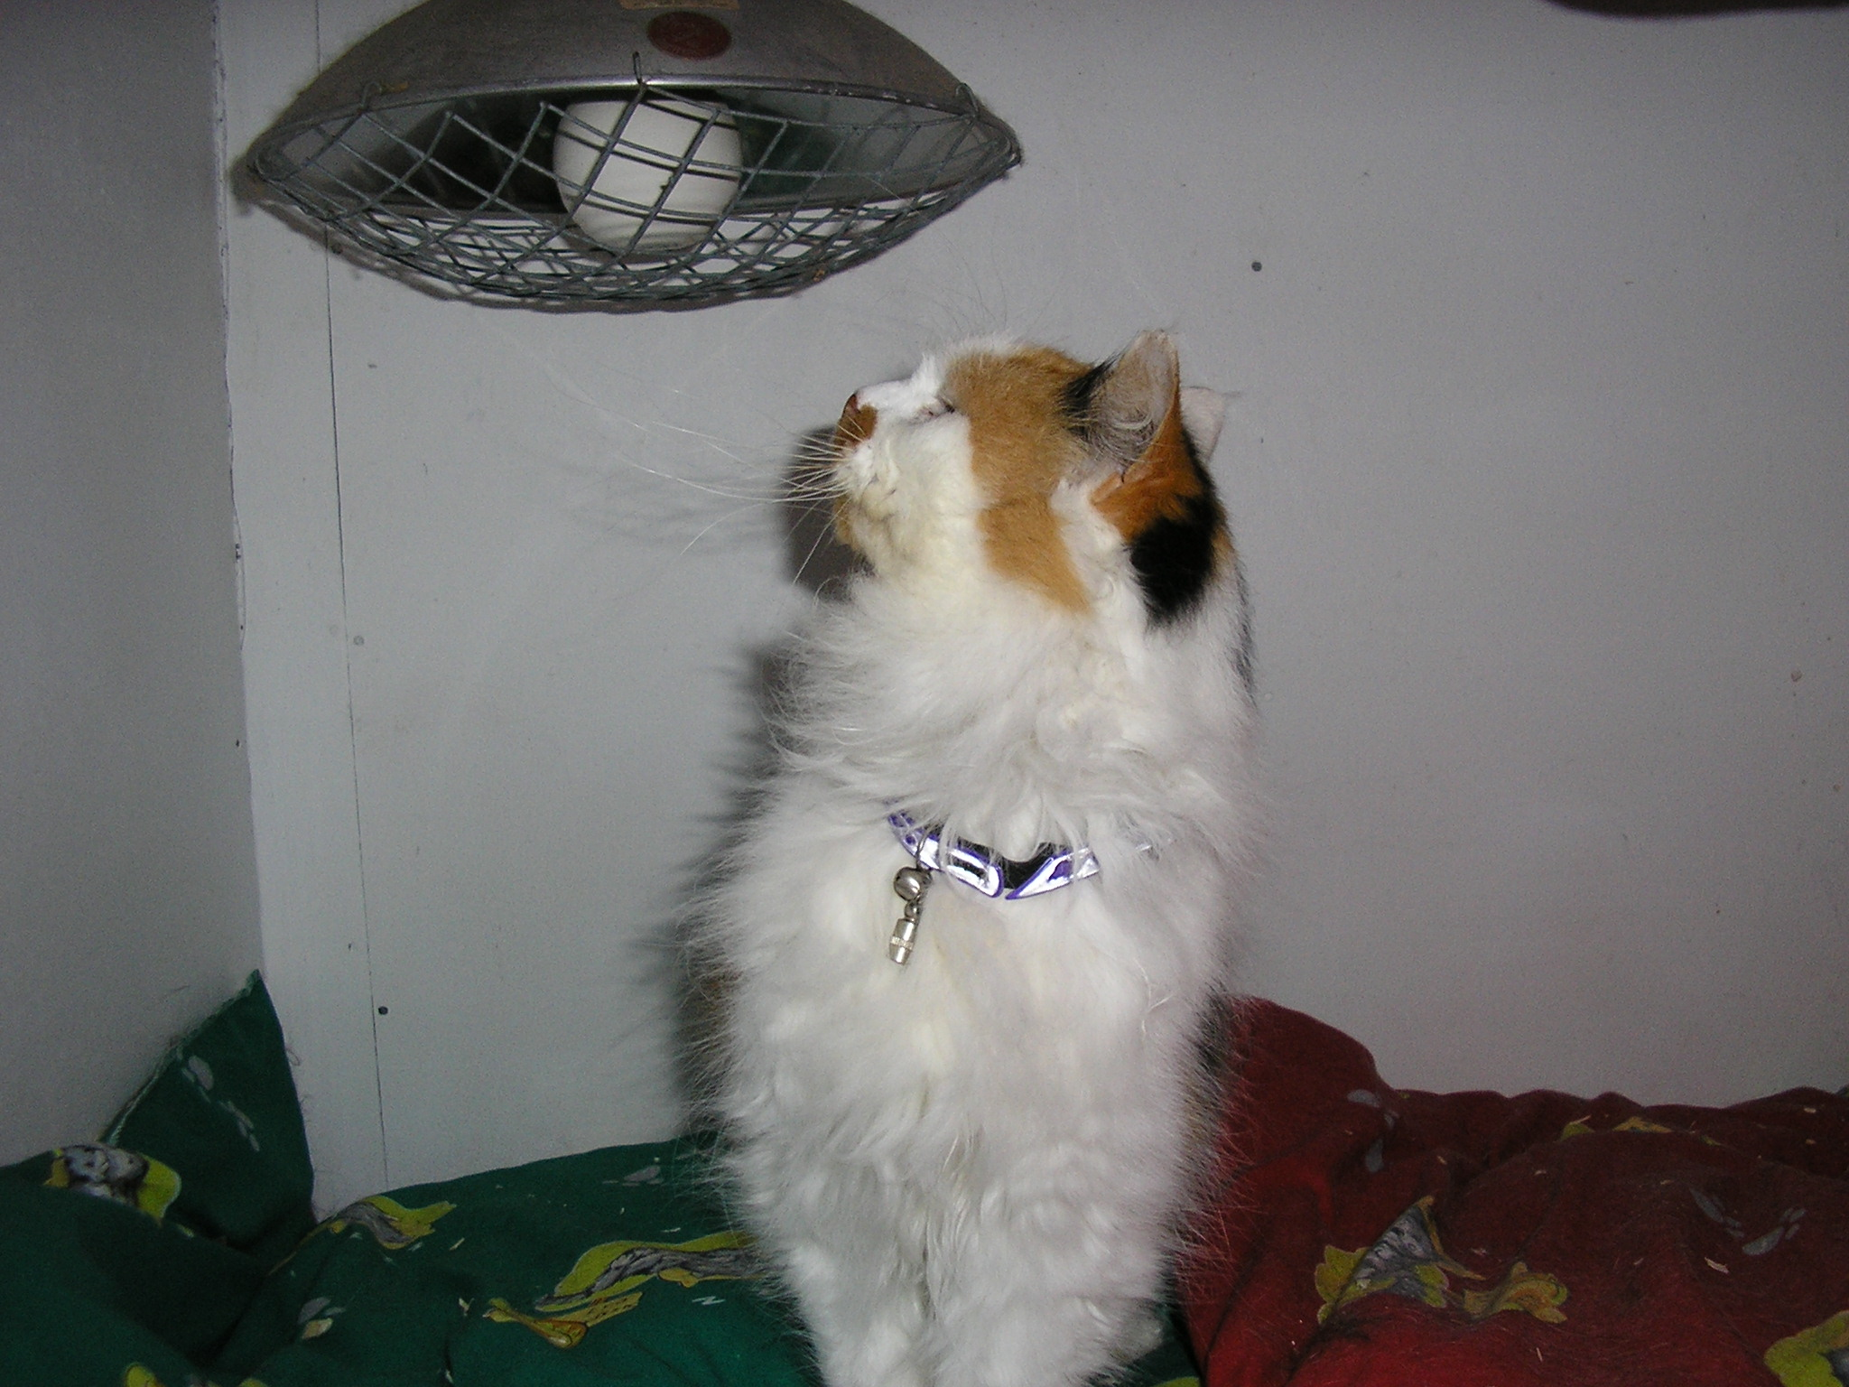

"Lotty" is a long-haired tortoise shell and white cat.
She is a female of about 6 or 7 years.
Very affectionate and would suit someone looking for companionship.
We also have a lovely caramel/black long eared rabbit who was found hopping around a Harrogate Town Centre Car Park earlier this week The rabbit is currently being boarded in the hope that an owner will come forward. The rabbit has been nicknamed “Debbie” as he/she was found in the car park at the back of Debenhams!
Harrogate Town Football Club
Harrogate Town Football Club have donated two signed footballs to the Branch. We will be able to raffle them off at future events. They are to be presented to the Branch at half time in one of their home games. I am just waiting for confirmation of the date, it will be either 19th March or 16th April. They have agreed that we can collect on behalf of the Branch in the ground on the day. They will also arrange for their photographer to cover the presentation. I think this is a good opportunity for the Branch and Harrogate Town to get some good PR.
We will need volunteer collectors on the day and you get entry to the match! If you are interested please can you let me know asap. I will hopefully be able to confirm the date by the 10th February.

Knaresborough Pet Day
Monday May 2nd 2005
The Branch will be actively involved with the Pet Day, we will be running a qualifying heat for Rescue Dog of the Year as well as having several stalls and offering microchipping. If you are interested in running a stall or helping in anyway please let me know. I do need people to help organise the following stalls ; cakes & biscuits, , jam jar stall, plus any games or stalls we may have there on the day. Please do support this event as it is a real opportunity for us to raise the Harrogate & District Branch profile and to raise much needed funds.

Waifs & Strays Lottery
January Winners
1st Prize – £50 - Number 3 – Shirley Neal
2nd Prize – £20 - Number 15 – Gemma Johnson

If you would like to join the lottery and support the Branch as well as having the opportunity to win a monthly cash prize, please contact Jill on 01423 886249.

Information session for potential trustees of the Branch.
The Branch will be holding an informal session for anyone who may be interested in becoming a trustee of the Branch. The object of the session will be to inform people of what is involved in becoming a trustee and answer any questions. We have also invited a trustee from another Branch to explain her role. The session will be held in March 2005, date to be confirmed.
We would hope to have a number of nominations for committee members when we hold the Annual General Meeting. Date to be confirmed.

Target Neutering Campaign
The Branch has recently held a Target Neutering Campaign for Cats. Anyone who was in receipt of an income based benefit could apply to have their cats neutered at participating Vets for free. The campaign resulted in over 100 vouchers being issued in the Harrogate area. Just think how many kittens would have been born as a result of these cats not being neutered! We hope to run a similar scheme in the future.

Friends Meeting
The next meeting will be held on Thursday 17th February @ 7.30pm at The Kestrel, Wetherby Road Harrogate. Please do come along and support the Branch you will be very welcome. We will be discussing forthcoming fundraising events and it is an opportunity for us all to meet socially. If you have not been to a meeting before and are worried about coming in and not knowing anyone please let me know you are coming and we will make sure you are given a friendly welcome. Any suggestions about future fundraising events you would like to see in the diary
then please put them forward. It has been suggested it would be nice to have a guest speaker every now & then, i.e. local vet, RSPCA Inspector, etc. I think this is a great idea but we do need to have a good turnout at our meetings otherwise it is not justified. There is so much potential for the Harrogate & District Branch to move forward this year and with your help it will.

Diary Dates so far……
Pets Photographic Competition – Feb 14th – May 27th 2005
Friends Meeting – Feb 17th @ 7.30pm The Kestrel Wetherby Road Harrogate

Coffee Morning – March 16th @ Collingham Village Hall

Knaresborough Pet Day – Monday 2nd May

Harrogate Flag Day – Saturday 25th June

Ripon Flag Day – Saturday 16th July

Knaresborough Flag Day – Saturday 6th August
August – Microchipping Campaign

Sainsburys Collection Day – Saturday 3rd September

November – Games night & Supper.

December – Xmas Fayre

