

Harrogate & District Branch Newsletter
Registered Charity No. 232219

February 2010
www.rspcaharrogate.org.uk

BRANCH CONTACT DETAILS

Branch Manager – Jill Johnson
PO Box 608
Harrogate
HG1 9EY
01423 886249
e-mail: RSPCA.Harrogate@ic24.net

If you need to report an animal in distress or an emergency,
Please contact the RSPCA 24-hour Cruelty and Advice line
0300 1234 999

Stray Dogs
Neither the RSPCA nor the police can deal with stray dogs, which are the responsibility of the Dog Warden Service. The numbers to ring about strays are now:

If you find a dog
Please ring 01423 556633 or 01423 500600 during office hours
or 07525 988048 for the Out of hours stray dog reception.

If you have lost a dog
Please ring 01423 556633 or 01423 500600 during office hours or
07525 988048 for the Out of hours stray dog reception.

BRANCH & ANIMAL UPDATES

Where did 2009 go? As a Branch we had a fantastic year despite a very difficult economic climate. We re-homed 45 cats and kittens throughout the year which was well up on 2008. Kittens started arriving early April and continued until November. We also had some lovely cats come in and most of them were re-homed fairly quickly.

The Branch dog and cat neutering campaigns that were held throughout the year were a huge success and resulted in 27 dogs and 116 cats being neutered. We do try to help people that are unable to have their animals neutered and are on income based benefits.

During October we held the microchipping campaign with the support of several local vets. It was the best year we have had to-date and resulted in 295 dogs and cats being chipped. This is also a major fundraiser for the Branch and a very big Thank You to the following Vets for supporting our campaign.

Vets4Pets Harrogate
Forest House Knaresborough
Hutchinson Dunlop & Baird Wetherby
Westwood Veterinary Group Boston Spa
Rae Bean & Partners Boroughbridge
Bishopton Veterinary Group Ripon

The Branch lottery has gone from strength to strength this year and provides nice cash prizes but most importantly brings in much needed funds.

I would also like to say Thank You to all the fantastic volunteers we have in whatever capacity, those of you who give your continued to support to fundraising, and our home visitors who give their time. It is so much appreciated by me.

Finally, our Trustees whose help is invaluable to the Branch and myself.

Vets4Pets Vacs4Life Special Offer
The RSPCA believe that prevention is always better than cure and vaccinations for cats and dogs are one of the most important ways we can protect them from many life threatening diseases.

The branch is therefore really excited to hear that Harrogate Vets4Pets are offering a fantastic deal to all cat and dog owners from 22nd February to 20th March.

During this period, for a one off payment of £99 they will vaccinate your pet, and then every year after that for free.

They have worked it out that if you bought this for a puppy, you could save over £350 over the lifetime of the dog. And for a kitten, you could save more than £400 over the life of the cat!

And that’s not the only good thing, for every Vacs4Life policy they sell, Harrogate Vets4Pets will donate £5 to the RSPCA to help us to continue our work with animals in need in Harrogate.

Needing homes
Robson and Jerome are two lovely black and white neutered male cats aged about three years old. They came into the Branch in October along with a six month old kitten. They are lovely cats, a little bit shy but once they get to know you are very affectionate. Ideally they need to go to a home with no young children. They will make lovely pets. 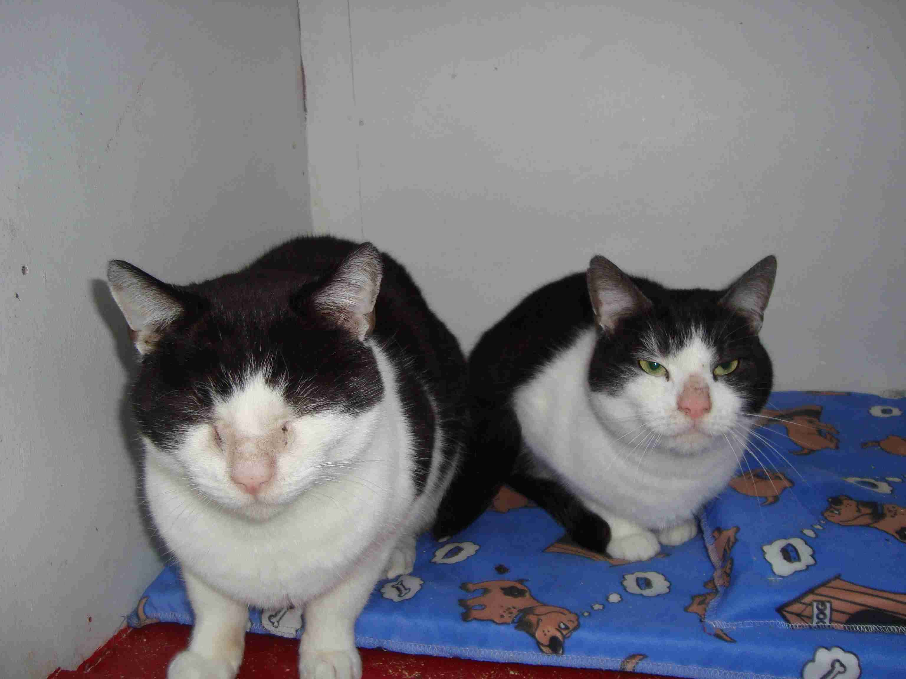

Fundraising
I am just in the process of putting together our events programme for 2010 and am still awaiting confirmation of a number of dates. The events page shows dates that have confirmed so far and I will send an updated event sheet to everyone as soon as all the dates have been confirmed.

I have written to supermarkets and both Leeds and Harrogate Councils for permits. In addition we are looking to hold 2 quiz nights, Southlands Dog Show and several new events in 2010.

If anyone would like to participate in The Nidderdale Charity Walk and raise sponsorship on behalf of the Branch. Please let me know as Branch will pay the entry fee for the walk.

Lottery Updates
September – 1st Karen Codling (28)
- 2nd Vicky Crawley (20)
October - 1st Jane Davison (29)
- 2nd Shelley Devonshire (54)
November - 1st Jeanne Thompson (43)
- 2nd Jackie Paradis (2)
December - 1st Claire Porter (56)
- 2nd Colin Devonshire (55)

EVENTS DIARY 2010

February
Wednesday 24th | Friends Meeting @ The Kestrel @ 7.30pm
March
Saturday 13th | Coffee Morning Wetherby

April
Thursday 8th | Collection @ Morrison’s Wetherby
 | RSPCA Week 26th April – 2nd May
Friday 30th | Golf Day @ Flaxby

May
Saturday 15th | Collection @ Morrison’s Boroughbridge
Sunday 16th | Nidderdale Charity Walk

June
Wednesday 9th | Branch AGM

July
Saturday 3rd | Wetherby Street Collection
Saturday 31st | Birstwith Show

August
Saturday 14th | Harrogate Street Collection
Saturday 21st | Collection @ Morrison’s Ripon

September
Saturday 11th | Collection @ Morrison’s Harrogate

October
Saturday 9th | Collection @ Sainsbury’s Harrogate
 | Branch Microchipping Campaign

November
Saturday 20th | Collection @ Morrison’s Boroughbridge

OVER TO YOU

We would love to include your stories and experiences in our newsletter.

Have you adopted a rescue animal?

Have you organised and event and would like to tell us about it?

Do you have a pet with attitude who would love to have their photo in print?

Please send your contributions via email or by post to have them included in the next edition of the Branch newsletter.

