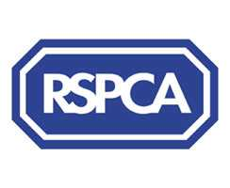

Harrogate & District Newsletter- January
Branch Administrator – Jill Johnson
Tel: 01423 886249
Website: www.rspcaharrogate.org.uk

Reg charity no 232219

Hello and Welcome to our first newsletter of 2006! I hope you have all had a great Christmas.
The format of this newsletter is slightly different from normal due to the fact I am doing a brief roundup of news from 2005 as well as current news. There is so much I could put in but it would take up pages and pages.

Thank You
I would just like to say a very big ‘Thank You’ to everyone who has volunteered in some way in 2005. With your support we have achieved so much and have come so far. I really could not do the job I do without the wonderful team of volunteers who support the branch.

Re-homing
Since January 2005 we have re-homed 10 cats, 13 kittens and 4 rabbits. The website has proved fundamental in the re-homing process, particularly with cats that are in need of new homes. All our animals for re-homing are fully vet checked, neutered, wormed and treated for fleas as well as microchipped. In addition to providing veterinary treatment for animals in our care we also provide welfare assistance to people on certain types of benefit on occasions where they may need help with neutering or vet bills.

Microchipping
We ran a very successful microchipping campaign in August in conjunction with several local vets, this resulted in over 150 animals being microchipped in the region. Our policy is to have as many animals microchipped as possible, if all pet owners had their animals microchipped we would not have as many problems with stray cats and dogs that we do. Our aim for 2006 is to offer a microchipping service at most events and run a local campaign again later in the year.

Neutering
As with microchipping we encourage owners to have their animals neutered in order to prevent unwanted pregnancies and in turn unwanted litters of puppies and kittens.
The Dogs Trust and RSPCA campaign has resulted in over 40 dogs being neutered, we still have some vouchers so if you know of anyone who is on benefit and has a dog that needs neutering do get them to contact me.
Throughout 2005 the branch has neutered 186 cats in addition to those that we have re-homed.

Fundraising
We have had a fantastic year for fundraising with many different events. We have had an event or some fundraising activity almost every month, which has resulted in fundraising income being substantially higher than in 2004. We have quite a full fundraising calendar for 2006, but if you have any suggestions or new ideas for events do let me know or come along to the next Friends Meeting and share them with us.

Friends Meetings
Throughout 2005 we held regular meetings at The Kestrel Pub in Harrogate, the meetings have proved very popular with a very good turnout on most occasions. It has been a great way to discuss fundraising events, share ideas and become friends and most importantly raise the profile of the branch and local animal welfare issues.
2006 will see the Branch again holding our meetings and hopefully increasing the number of people that come along.

Aims for 2006
Our aim for 2006 is to continue to promote animal welfare in the District and the work of the Branch. There is so much more we can do to help animals. We are still looking for suitable shop premises, hopefully in the very near future we will have the branch shop up and running! This will be a great way or raising the work and profile of the Branch. Do shout if you see any premises that you think might be suitable.
We are running a Branch campaign through the press and radio in January/February in order to attract people to volunteer in a number of different ways. As the Branch grows we need more volunteers to help us in our work in areas such as:

- Becoming a Trustee and helping to administer the affairs of the Branch
- Home Visitors
- Re-homing coordinator
- Fundraising
- Shop Volunteers

If you know of anyone who may be interested in helping in any way please ask them to come along to the next Friends Meeting or if they contact me I will send them an information pack. Details will also be posted on the website, which is www.rspcaharrogate.org.uk

Current news

Animals
December as expected was a very quiet month for re-homing, we do have a number of cats that are still looking for new homes. Some of them have been with us for a while so it would be great to see them in a proper home environment with loving new owners.
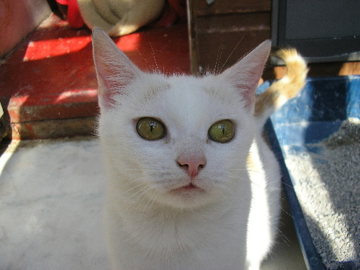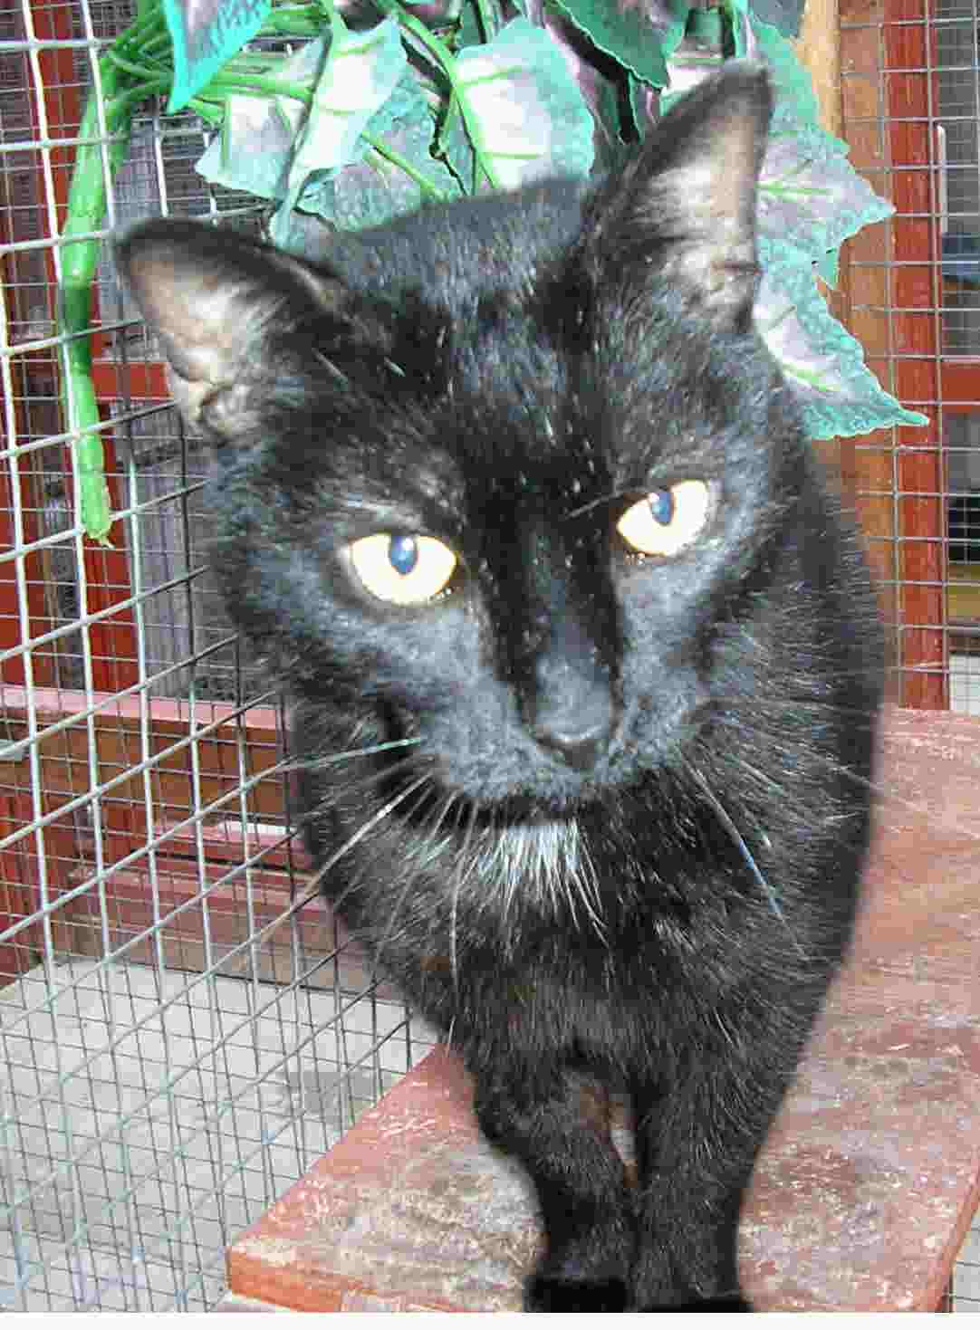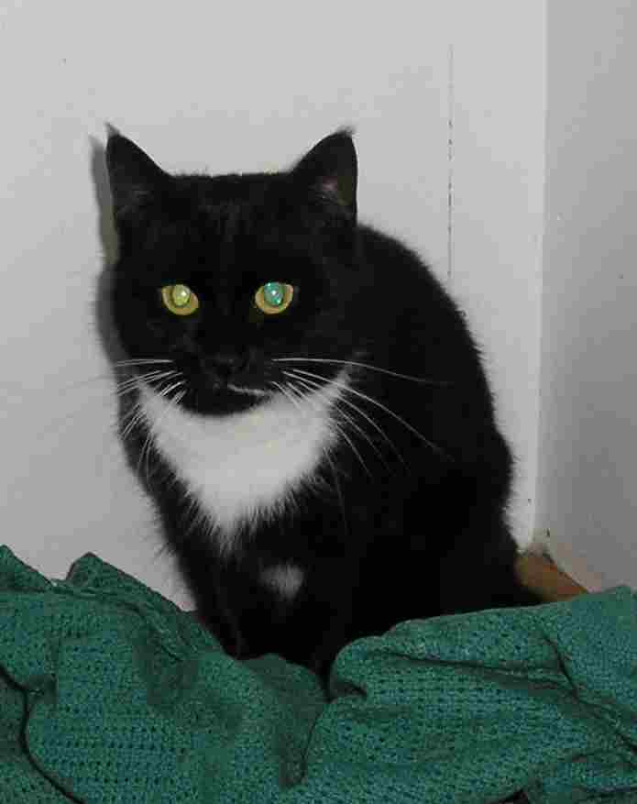

Jewel has been with us for some time now and is a lovely young female cat who is very playful and would be great for a family who would give her lots of attention.

Lucky is a black with a touch of white neutered male who is extremely affectionate, he was involved in a traffic accident but is now fully recovered. Lucky has only half a tail but this does not affect him in any way. He is looking for a quiet home with someone to give him lots of cuddles.

Vanilla is a neutered black and white female cat who came to us with her sister after they were abandoned. Her sister has now been re-homed. Vanilla has lots of love to give but is quite timid until she gets to know you. Vanilla needs to go to a home with no other pets.
If you can offer a loving permanent home to any of these cats please contact the branch.

Lottery
The branch lottery has been running for a whole year now and has brought a considerable amount of income into the branch. For £4 per month not only does it help animal welfare but there is the opportunity to win cash prizes every month. It really is a worthwhile way of helping the branch, if you would like to join please let me know and I will send you an application form. We do need to increase our membership numbers in 2006.

October winners
1st – Jean Gregg
2nd – Karen Codling

November winners
1st – Vicky Crawley
2nd – Jenny Haigh

Legacies
From time to time we receive a legacy from someone who has left money specifically to the Harrogate branch, this provides crucial funding which enables us to carry on with our work. Please find the enclosed branch leaflet which provides information on how you can leave a lasting legacy.

2006 Calendar

Saturday 14th January - Collection Day @ Morrisons Ripon If you can help for an hour or two please let me know asap, we do need more people to help!

January/February - Volunteer Campaign

Thursday 26th January @ 7.30pm - Friends Meeting @ The Kestrel Wetherby Road

1st March – 31st May – Short Story Competition – Details to follow shortly

April 2006 – Regional Snip & Chip Campaign

Saturday 29th April – Collection Day@ Morrisons Wetherby

Monday 1st May – Knaresborough Pet Day/Dog of the Year heat

Sunday 14th May – Nidderdale Charity Walk

June – Harrogate Flag Day

1st July –30th September – Pets Photo Competition

July – Birstwith Show
- Ripon Flag Day
- Wetherby Flag Day
- Great Yorkshire Show – 11th July – 13th July

August – Knaresborough Flag Day
- Starbeck Gala

September – Sainsburys Harrogate Collection Day
- Jumble Sale
- Microchipping Campaign

October – Morrisons Harrogate Collection Day
- Mutt Strutt
There are still a few dates to be confirmed but will hopefully have them all in place by the time I send the next newsletter out.

