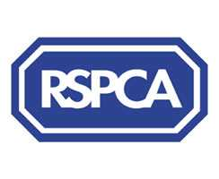

Harrogate & District Newsletter- June 07
Branch Administrator – Jill Johnson
Tel: 01423 886249
Website: www.rspcaharrogate.org.uk

Reg charity no 232219

Animal Update

I’m delighted to report that all of the cats that have been in our care for sometime have now been happily re-homed. You may remember Thai from our last newsletter, he has now been re-homed with Willow who was a very timid girl but adored Thai. Their new owners have told us they are very settled and much loved pets.
We do have a number of kittens (all reserved) but please if you are looking to re-home don’t forget the more mature cats who have so much to offer.

Recent admissions have included a budgie, and a ferret who decided to wander into someone’s kitchen and make himself at home! Brian as we decided to name the ferret was extremely friendly and smelly. He has now been transferred to ferret rescue where he will be neutered and hopefully re-homed.

Branch Neutering Campaign

The campaign was a huge success and resulted in over 80 vouchers being issued for both dogs and cats.
We have decided to re-run the campaign during the month of June 2007. Anyone who is on an income based benefit can apply for a voucher. The vouchers can be used at most vets throughout the district. If you know of someone who is struggling to pay to have their animal neutered please get them to contact the branch.

RSPCA Rehoming Week 20th – 28th October 2007

There will be a variety of awareness-raising issues and events taking place nationally. This will be the first official Re-homing Week which is intended to become an annual event. Watch this space for further information!

ANIMAL PHOTO COMPETITION

Entry Fee: £1 per photo per class
Prizes: Rossettes for 1st- 3rd for each class plus highly commended

All 1st prize winning photographs will be put forward and an overall winner will be chosen, the winner will receive a championship rosette and a special prize.

LAST DATE FOR ENTRIES 23RD JUNE 2007

Entry forms available from:

RSPCA Harrogate & District Tel: 01423 886249

Below is just one our entries, ‘Kaos’.
If you have any animal photos please enter as all proceeds go to help local animals.

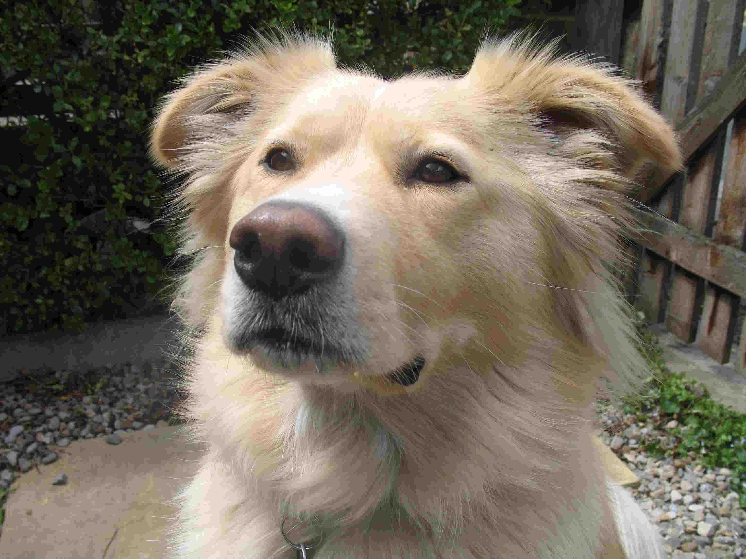

Recent Events

Thank you to all our volunteers who helped with Knaresborough Pet Day where over £141 was raised despite it being cold and showery.

Morrisons @ Wetherby raised £368 and a Coffee Morning @ Boston Spa raised £207. Thank you to our Wetherby volunteers for their fantastic efforts and to anyone who supported on the day.

Donation to Branch

We recently had a very generous anonymous donation. This has allowed the branch to purchase its own marquee and some tabards for use at events. For the volunteers who know how we struggle with the big HQ marquee this is fantastic news, delivery is expected any day! The tabards will replace the sashes we normally wear!!
I have passed on our grateful ‘Thanks’ to the donor.

Knaresborough Bed Race Sat 9th June 2007

We were recently approached by a local team who wanted to sponsor the branch at the above event. We are absolutely delighted that Tarzans & Jane will be promoting the branch.

So please come along and support the team either for the fancy dress judging at King James School field at noon, the parade through the town at 1pm or the race starting from Conyngham Hall at 3pm.

Hopefully we will have some pictures to put in the next newsletter!

New tail docking regulations and Dog Shows

The docking of dogs’ tails for cosmetic reasons in England & Wales has been banned with exemptions for ‘working dogs’ if certain conditions are satisfied. Under the new Act an offence is committed when a person shows a dog with a tail docked on or after the 6th April in England at an event to which members of the public are admitted on payment of a fee. The ban on showing includes docked ‘working dogs’ - unless these are shown ONLY for the purpose of demonstrating their working ability i.e. field trials – and dogs whose tails have been docked for purposes of medical treatment. The show organiser who allows a docked dog to enter their show maybe criminally liable. However, he or she will have a defence if they can show that they reasonably believed that the tail was docked prior to the new legislation coming into force.

A statement will be displayed at all future events so as to inform the public regarding the new legislation.

Southlands Dog Show Sat June 30th @ 2pm

BUPA Southlands on Ripon Road in Harrogate will be holding a dog show in their grounds at the rear of the home. All proceeds to the Branch. There will be a number of stalls and refreshments. Please do come along and support if you can. £1 per entry per dog.
Classes:
Veteran Dog (over 7 years)
The Dog with the Waggiest Tail
Most Obedient Dog
Rescue Dog

Volunteers Required

We have a number of events coming up (see events page) where we are short of volunteers. If you can help, even for just an hour please contact the branch.

The more money we raise the more we can do locally to help local animals. All help is greatly appreciated.

Rescue Dog of the Year
The local heat of Rescue Dog of the Year will be held at Birstwith Show this year on Saturday 28th July. Entries will be taken from 12.00pm. Any rescue dog is eligible to enter providing they are over six months old.
Our local sponsor for this event will be Mango Mutt.
There will also be a number of other dog classes.

Lottery
I’m really pleased to say we have had a few more people join the lottery over the last couple of months. However, the more people that are in it the more we can do locally. Your support would be very much appreciated.

February Winners
1st Kirsty Hollingworth (9)
2nd Jean Irving (44)

March Winners
1st Kirsty Hollingworth (9)
2nd Sally Robinson (5)

EVENTS 2007

Dog/Cat Neutering Campaign - June

Saturday 9th June – Knaresborough Bed Race – Branch supported by “Tarzans & Jane”

Saturday 23rd June – Harrogate Flag Day – COLLECTORS NEEDED

Saturday 30th June – BUPA Southlands (Ripon Road, Harrogate) – Dog Show @ 2pm

Sunday 1st July – Wetherby Pram Race –RSPCA Stall

Saturday 14th July – Wetherby Flag Day – COLLECTORS NEEDED

Tuesday 17th July – Friends Meeting @ The Kestrel @ 7.30pm – All Welcome

Saturday 28th July – Birstwith Show & Dog Show Classes including Heat of Rescue Dog of the Year

Saturday 4th August Morrisons Collection Boroughbridge - COLLECTORS NEEDED

Monday 27th August Starbeck Gala & Dog Show – GALA IS NOW BACK ON

Saturday 1st September – Morrisons Collection Starbeck – COLLECTORS NEEDED

Tuesday 18th September – Friends Meeting @ The Kestrel @ 7.30pm – All Welcome

Branch Microchipping Campaign – September

Thursday 4th October – Autumn Fayre @ Wetherby Town Hall

Saturday 20th October Sainsbury’s @ Harrogate Collection

Saturday 27th October Morrisons @ Boroughbridge Collection

Mutt Strutt – October – Date to be confirmed

Saturday 10th November – Jumble Sale @ Hampsthwaite Village Hall

