

Harrogate & District Newsletter- March 07
Branch Administrator – Jill Johnson
Tel: 01423 886249
Website: www.rspcaharrogate.org.uk

Reg charity no 232219

Animal Update
I am delighted to report that the branch has re-homed eight cats during January and February, this really is a fantastic start to the year. However, as always there are more cats waiting to be re-homed.

Billy
Billy is a lovely neutered tabby male, he is quite shy until he gets to know you. We think he is about two years old.

Thai & Maggie



Thai and Maggie came to us in February when their owner was moving house and decided she did not want them anymore. Unfortunately Maggie had an infection in her mouth that had gone untreated and has subsequently had to have thirteen teeth removed. She is now back to full health and is full of fun, she is only about two years old and is a black and white neutered female.
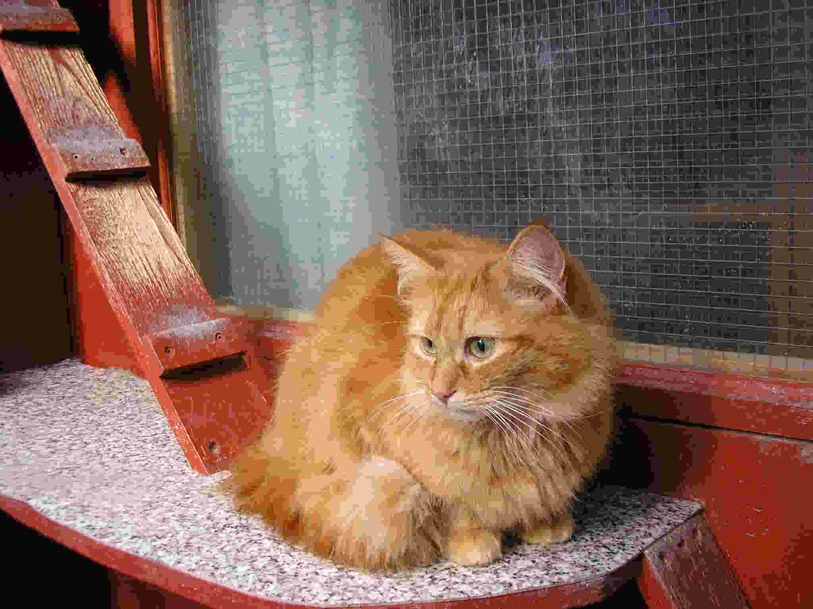

Thai is a beautiful ginger neutered male who we think is about 4 years old, he also had an eye infection which had gone untreated but is now fit and healthy.
They are beautiful loving cats who absolutely adore each other and love human contact. If you can offer a new loving home to Thai and Maggie please contact the branch.

Success Stories
Meet Claude and Polly having fun in their new home! They came to us with their mum and another kitten back in November. Happily all were re-homed very quickly and the picture below was sent to us by their new owner. It’s always nice to get updates on animals that have been in our care.
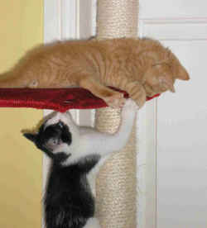

Foster homes
As we are approaching kitten season we are looking people to act as short term fosterers for kittens that come into our care. Usually the
kittens are not quite old enough to go to new homes. Ideally we like them to go to a home environment so they can get lots of love and become socialised before they are re-homed. If you think you can help or would like a chat about what is involved please contact the branch.

Branch Neutering Campaign
The branch is running a full cost neutering campaign for both cats and dogs during the months of February and March 2007. Anyone who is on an income based benefit can apply for a voucher. The vouchers can be used at most vets throughout the district. We have had a fantastic response to date with 47 vouchers being issued in February. If you know of anyone who may be interested please ask them to contact the branch.

Coffee Morning Boston Spa Village Hall Saturday 31st March 07 between 10.00am – 12.00pm
Please come along and support the Branch, there will be lots of stalls, a competition with a free goody bag for each entrant. There will also be a branch information stand and an RSPCA Inspector present to answer any questions.

Mango Mutt
We are very pleased to that a local company Mango Mutt has become involved with the branch and will be the main sponsor for our dog events this year. They will also be involved in promoting responsible dog ownership in our area. Go to www.mangomutt.co.uk and see what fantastic products are available. Quote RSPCA Harrogate and you will receive 10% off your first order.

Rescue Dog of the Year
The local heat of Rescue Dog of the Year will be held at Birstwith Show this year on Saturday 28th July. Entries will be taken from 12.00pm. Any rescue dog is eligible to enter providing they are over six months old.
Our local sponsor for this event will be Mango Mutt.
There will also be a number of other dog classes.

Lottery
The branch lottery has been running for over two years and has made a substantial amount of money which goes towards the cost of the animals in our care as well as providing monthly cash prizes.

However numbers are seriously down in 2007 and unless we have a minimum of another six people

joining quickly we will no longer be able to continue. The law requires us to have a minimum number of entrants and we are at that point now. Please if you can support the branch by joining the lottery please get in touch asap for an entry form. It only costs £4 per month and you would be doing so much to help local animal welfare.
There is a £50 and £20 cash draw each month as well as a mega draw in March and September with cash prizes of £100 and £40.
You have to be in it to win it!

Lottery Winners
November 06
1st – Ruth Greenwood (41)
2nd – Pat Bickerdike (38)
December 06
1st – Jeanne Thompson (43)
2nd – Karen Littler (37)
January 07
1st – Christopher Davison (33)
2nd - Peter Bolton (23)

Donations
I would just like to say a big Thank You to Lisa Sienkiewicz who recently had her 30th birthday and instead of receiving presents asked her friends to make out cheques to the branch. £159.35 has been donated to the branch. Happy Belated Birthday Lisa and thank you again for your generosity.

ANIMAL PHOTO COMPETITION

Entry Fee: £1 per photo per class
Prizes: Rossettes for 1st- 3rd for each class plus highly commended

All 1st prize winning photographs will be put forward and an overall winner will be chosen, the winner will receive a championship rosette and a special prize.

LAST DATE FOR ENTRIES 23RD JUNE 2007
ALL PROCEEDS HELP LOCAL ANIMALS

Entry forms available from:
RSPCA Harrogate & District Tel: 01423 886249
0R
by downloading form from www.rspcaharrogate.org.uk

Class 1 Best Dog
Class 2 Best Cat
Class 3 Any other animal
Class 4 Wildlife in Natural Habitat

All photographs will be displayed in Harrogate Library from Monday 9th July 07 until Saturday 21st July 07

For further information please contact Jill on 01423 886249

EVENTS 2007

Dog/Cat Neutering Campaign – February/March

Saturday 31st March Coffee Morning @ Boston Spa Village Hall 10.00-12.00

Saturday 28th April Morrisons Collection Wetherby

Tuesday 1st May – Branch AGM @ The Kestrel Wetherby Road @ 7.30pm

Monday 7th May – Knaresborough Pet Day

Tuesday 15th May – Friends Meeting @ The Kestrel Wetherby Road @ 7.30pm

Saturday 23rd June – Harrogate Flag Day – COLLECTORS NEEDED

Saturday 28th July – Birstwith Show & Dog Show Classes including Heat of Rescue Dog of the Year

Saturday 4th August Morrisons Collection Boroughbridge - COLLECTORS NEEDED

Monday 27th August Starbeck Gala & Dog Show

Branch Microchipping Campaign – September

Jumble Sale @ Hampsthwaite – Date to be confirmed

Thursday 4th October – Autumn Fayre @ Wetherby Town Hall

Saturday 20th October Sainsbury’s @ Harrogate Collection

Saturday 27th October Morrisons @ Boroughbridge Collection

Mutt Strutt – October – Date to be confirmed

