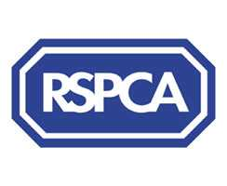

Harrogate & District Branch Newsletter
Registered Charity No. 232219

October 2009
www.rspcaharrogate.org.uk
BRANCH CONTACT DETAILS

Branch Manager – Jill Johnson
PO Box 608
Harrogate
HG1 9EY
01423 886249
e-mail: RSPCA.Harrogate@ic24.net

If you need to report an animal in distress or an emergency,
Please contact the RSPCA 24-hour Cruelty and Advice line
0300 1234 999

Stray Dogs
Neither the RSPCA nor the police can deal with stray dogs, which are the responsibility of the Dog Warden Service. The numbers to ring about strays are now:

If you find a dog
Please ring 01423 556633 or 01423 500600 during office hours or 07525 988048 for the Out of hours stray dog reception.

If you have lost a dog
Please ring 01423 556633 or 01423 500600 during office hours or 07525 988048 for the Out of hours stray dog reception.

BRANCH & ANIMAL UPDATES

Since early April we have had a constant stream of cats and kittens coming to us. Several litters have been born up at the cattery and have been happily re-homed as soon as they were old enough. I’m very pleased to report that it’s not only kittens we have been able to re-home but older cats too.
Mabel and Molly were dumped at the vets aged 3 weeks after mum was killed in a road traffic accident. I took both kittens home and both thrived on bottle feeds and lots of tlc, they were extremely noisy and demanding kittens but both have been re-homed to loving new families. Mabel’s (picture below) family send me regular updates which is lovely.

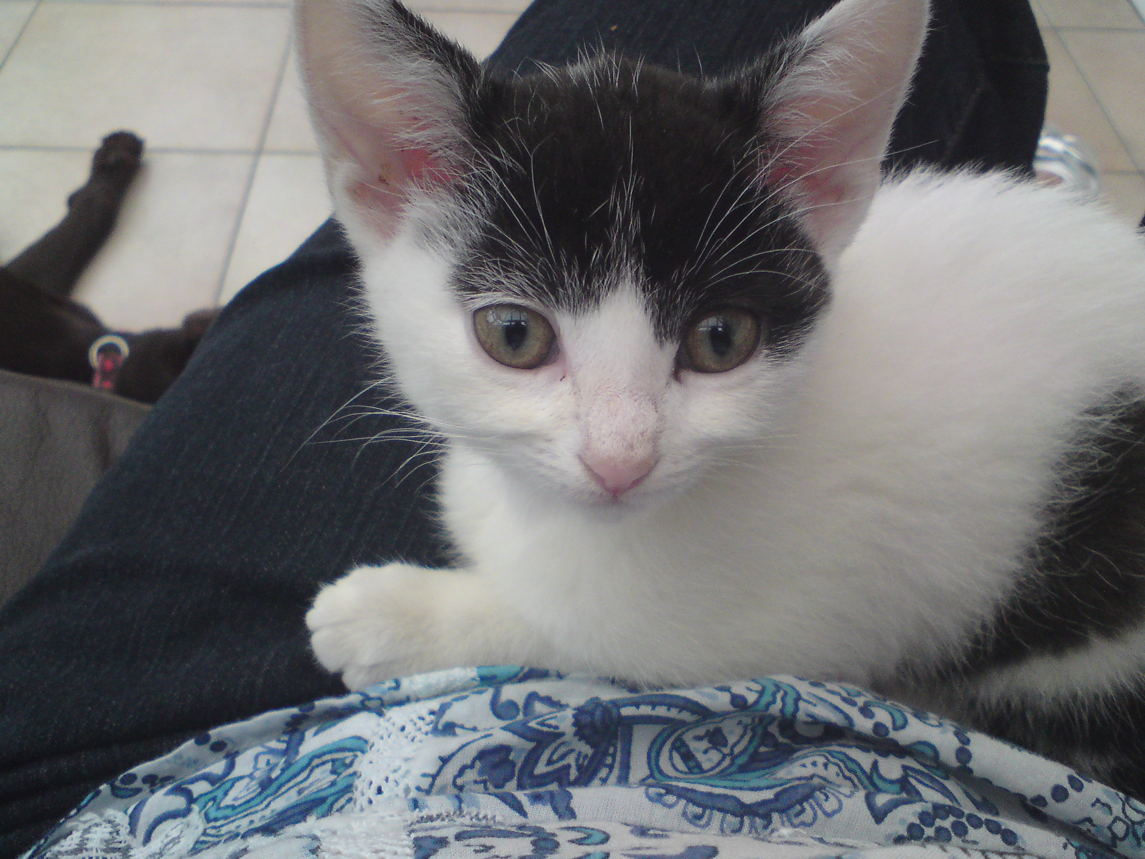

Needing homes
Trixie is a lovely tortieshell female aged about 4 years. She has been with us for some time now and is looking for a loving quiet home where someone will give her lots of attention.
Scooby is a 12 week old black and white kitten who is desperate for a new family who will give her lots of attention and playtime. She needs to go to a home with no young children.

Fundraising
A big Thank You to BUPA Southlands Nursing Home who held their annual dog show and fun afternoon to raise funds for the Branch. Over £400 was raised and a good time had by all. The home puts on lovely cream teas and home baked cakes and doggie treats too!
Birstwith Show saw over 80 entries for the various dog classes that we run. It’s lovely to see people returning to the show time after time to participate in the dog show. The weather was very kind to us and we all thoroughly enjoyed our day. A big Thank You to Trophy Leeds (Vicki and Tim) and
Leigh-Anne at Vets4Pets Harrogate for supplying the prizes for the dog show classes.
We have had several supermarket collections over the past few months and they really do make such a difference to our funds. I would just like to say a Big Thank You from me to all our volunteers who participate in whatever capacity, your support is invaluable. Also, Thank You to the Wetherby ladies who raise funds on behalf of the branch at various events in Wetherby and District.
We have still got events in the diary, please see events page for up todate information.

Lottery Updates
April - 1st Hannah Jagucki (57)
2nd Geoff Brown (49)
May – 1st Ruth Greenwood (41)
2nd Julia Moore (22)
June – 1st Jean Irving (44)
2nd Claire Porter (56)
July – 1st Derek Johnson (19)
2nd Jenny Haigh (60)

Touch
In place of the July Friends Meeting, we were invited to Touch Canine Care Centre just outside of Harrogate. The centre uses hydrotherapy and physiotherapy to treat dogs with various conditions. It was really interesting and informative to hear all about the centre and see some the patients in action in the pool. Thank You to Kay for putting the evening on for us and watch this space as we are planning a joint event for next year.

Branch Microchip Campaign
1st October – 31st October 2009
The veterinary surgeries taking part are:

- Hutchinson, Dunlop & Baird, Wetherby, Tel: (01937) 582025
- Vets4Pets, Harrogate, Tel: (01423) 886666
- Forest House Vets, Knaresborough, Tel: (01423) 862121
- Rae, Bean And Partners, Boroughbridge, Tel: (01423) 322316
- Westwood Veterinary Group, Boston Spa, Tel: (01937) 842210
- Westwood Veterinary Group, Garforth, Tel: (0113) 2320085
- Bishopton Veterinary Group, Ripon, Tel: (01765) 602396

The cost is just £12.50 and we hope many people will take this opportunity to have their pet chipped.

Why do we microchip?
When you adopt a cat or dog from your local RSPCA they are microchipped and your address and details will be registered in the national database. We do this because the RSPCA believes that the best way to make sure you find a missing pet is to have it “chipped”.
How does it work?
Once an animal has been microchipped, it has its own unique code number. The owner’s details and the code are entered into the national Petlog computer database. If a lost or stolen animal is found, the code will be revealed by passing a scanner over the chip. Most vets, RSPCA inspectors, council refuse offices and dog wardens have a scanner.
Even though your pet may wear a collar with your details these are easily lost or removed but the chip is permanent. The normal cost of microchipping varies between £20 - £30. It is as simple as an injection. A small chip, the size of a grain of rice, is inserted under the skin between the shoulder blades.

Forthcoming Events
Tombola /Raffle Prizes – We have a couple of events coming up before the end of the year and we are very short of prizes. If you can donate any prizes we would be very grateful.

Jumble Sale at Hampsthwaite Memorial Hall on Saturday 7th November, doors open at 1pm. Raffle prizes and jumble needed please. Jumble can be left at the hall on the morning of the sale from 10.00am.

Quiz Night to be held on Tuesday 1st December at The Smiths Arms @ Beckwithshaw @ 7.30pm. Ticket price is just £5 to include curry and quiz.
A great night was had by all last year and over £400 was raised for the branch. Contact the Branch for ticket sales, early booking is advisable as ticket numbers are limited. If last year was anything to go by we were actually turning people away!

Xmas meal will be held on Friday 4th December at The Wing Wah Chinese Restaurant in Harrogate, cost will be approximately £13 for the chinese buffet. Claire has very kindly offered to co-ordinate this for us and she can be contacted on 07532 273718. The cut off date for booking a place is Friday 12th November. The meal is open to all volunteers and friends of the branch.

EVENTS DIARY 2009

November
Saturday 7th | Jumble Sale @ Hampsthwaite Memorial Hall
Saturday 7th | Xmas Fayre @ Wetherby
Tuesday 24th | Friends Meeting CANCELLED

December
Tuesday 1st | Quiz night @ The Smiths Arms Beckwithshaw
Friday 4th | Xmas Meal @ Wing-Wah Harrogate

OVER TO YOU

We would love to include your stories and experiences in our newsletter.

Have you adopted a rescue animal?

Have you organised and event and would like to tell us about it?

Do you have a pet with attitude who would love to have their photo in print?

Please send your contributions via email or by post to have them included in the next edition of the Branch newsletter.

