

Harrogate & District Newsletter- Sept 06
Branch Administrator – Jill Johnson
Tel: 01423 886249
Website: www.rspcaharrogate.org.uk

Reg charity no 232219

Fundraising
We have had a number of events over the summer to raise funds for the Branch.
Southlands Nursing Home Dog Show raised £153, we are now hoping to have this as an annual event.
Ripon, Wetherby and Knaresborough Flag Days raised over £500.
Wetherby Church Fete and Pram Race raised almost £400.
Birstwith Show & Dog Show raised £309
Starbeck Gala & Dog Show raised £280.
Without holding these fundraising events we would not be able to carry out the vital work we do for animals in the district.
We still have events (see events diary) happening every month for the rest of 2006, so please support when you can, it is very much appreciated

Annual General Meeting
This will be held on Monday 30th October @ 7.30pm @ The Kestral Wetherby Road Harrogate. The meeting is open to anyone to come along. However, only society members are eligible to vote. Please do come along and support us we need a minimum of 10 members for the meeting to have a quorum.

This is a very exciting meeting for us as we now have 7 members who are hoping to be voted in as trustees. This will then take the Branch from Council Trusteeship and back into local Trusteeship. Our guest speaker will be Inspector Mike Pugh who will tell us a little about the work he does locally.

Animals

Re-homing update
July and August have been very quiet on the rehoming side. Although all the kittens we had have now been re-homed we do have some lovely adult cats looking for new homes.

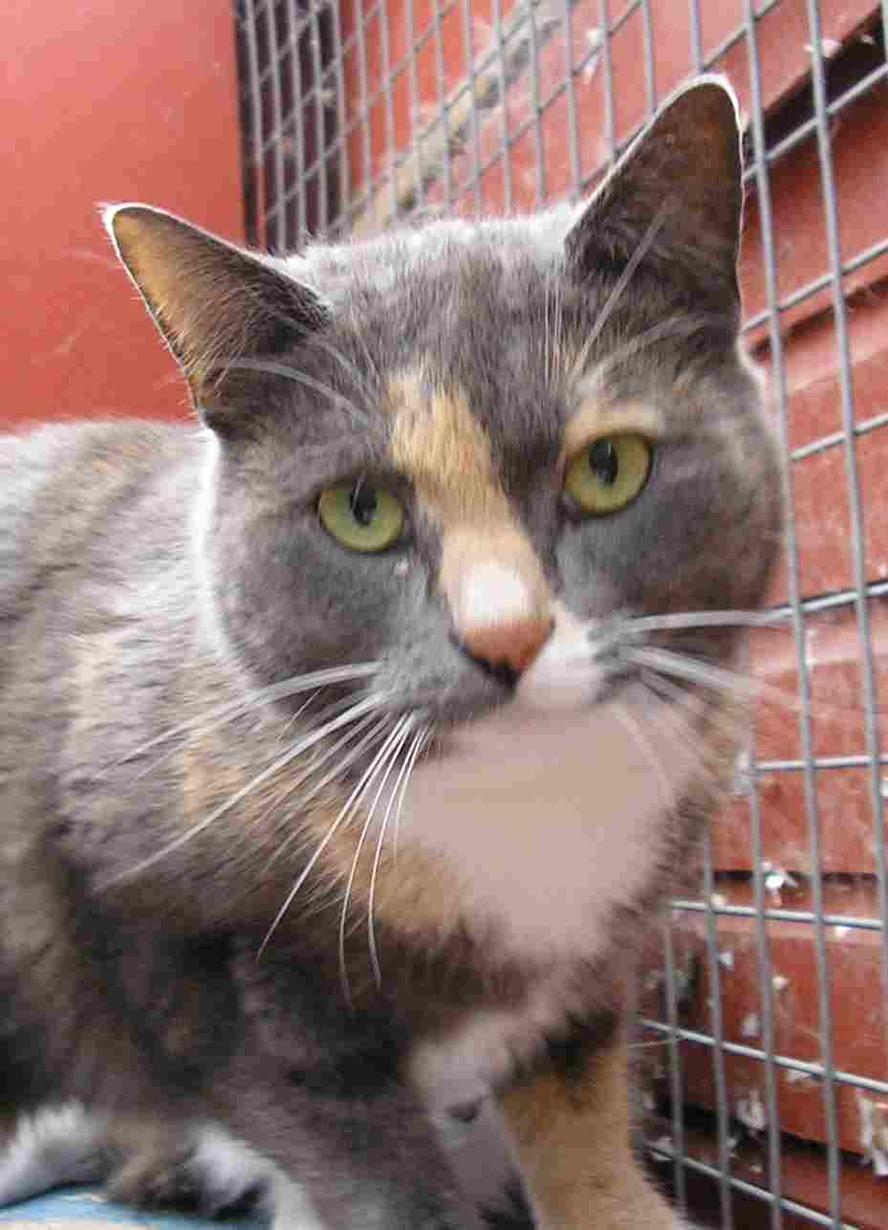

Dolly is a young very pretty peach and grey neutered female. We think she is about 2 years old. She is very affectionate is looking for a loving new home.

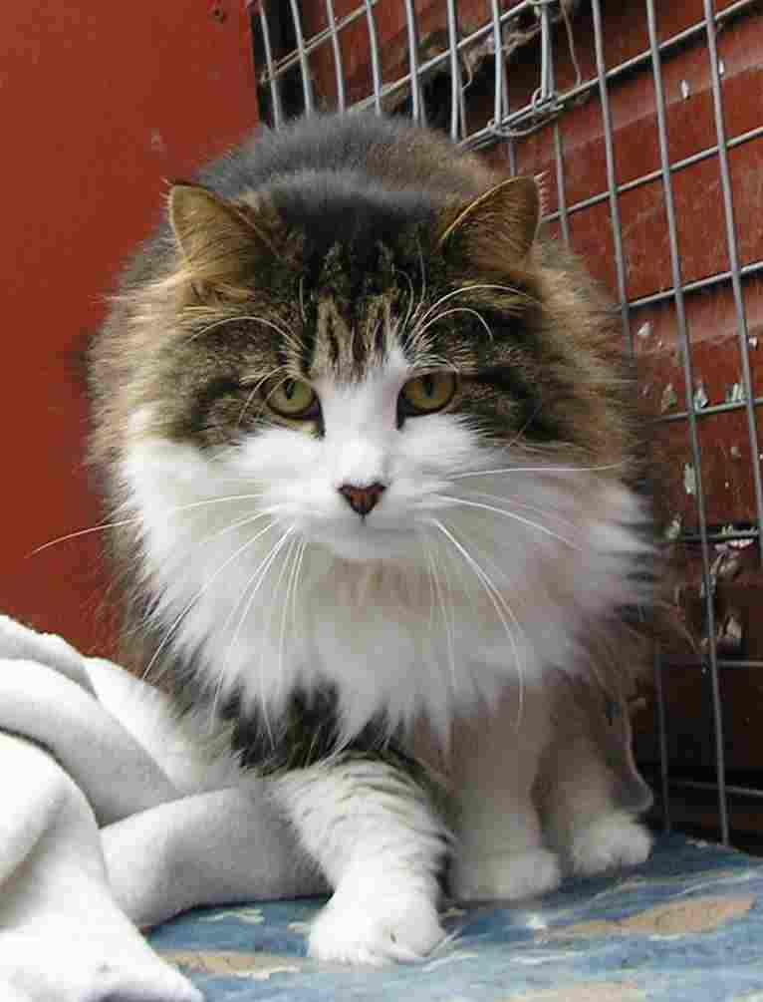

Daydream is a long haired tabby and white neutered male. He is aged 2/3. He is very quiet and laid back. He is looking for a home where is will make an ideal companion for someone who has no other pets or children.

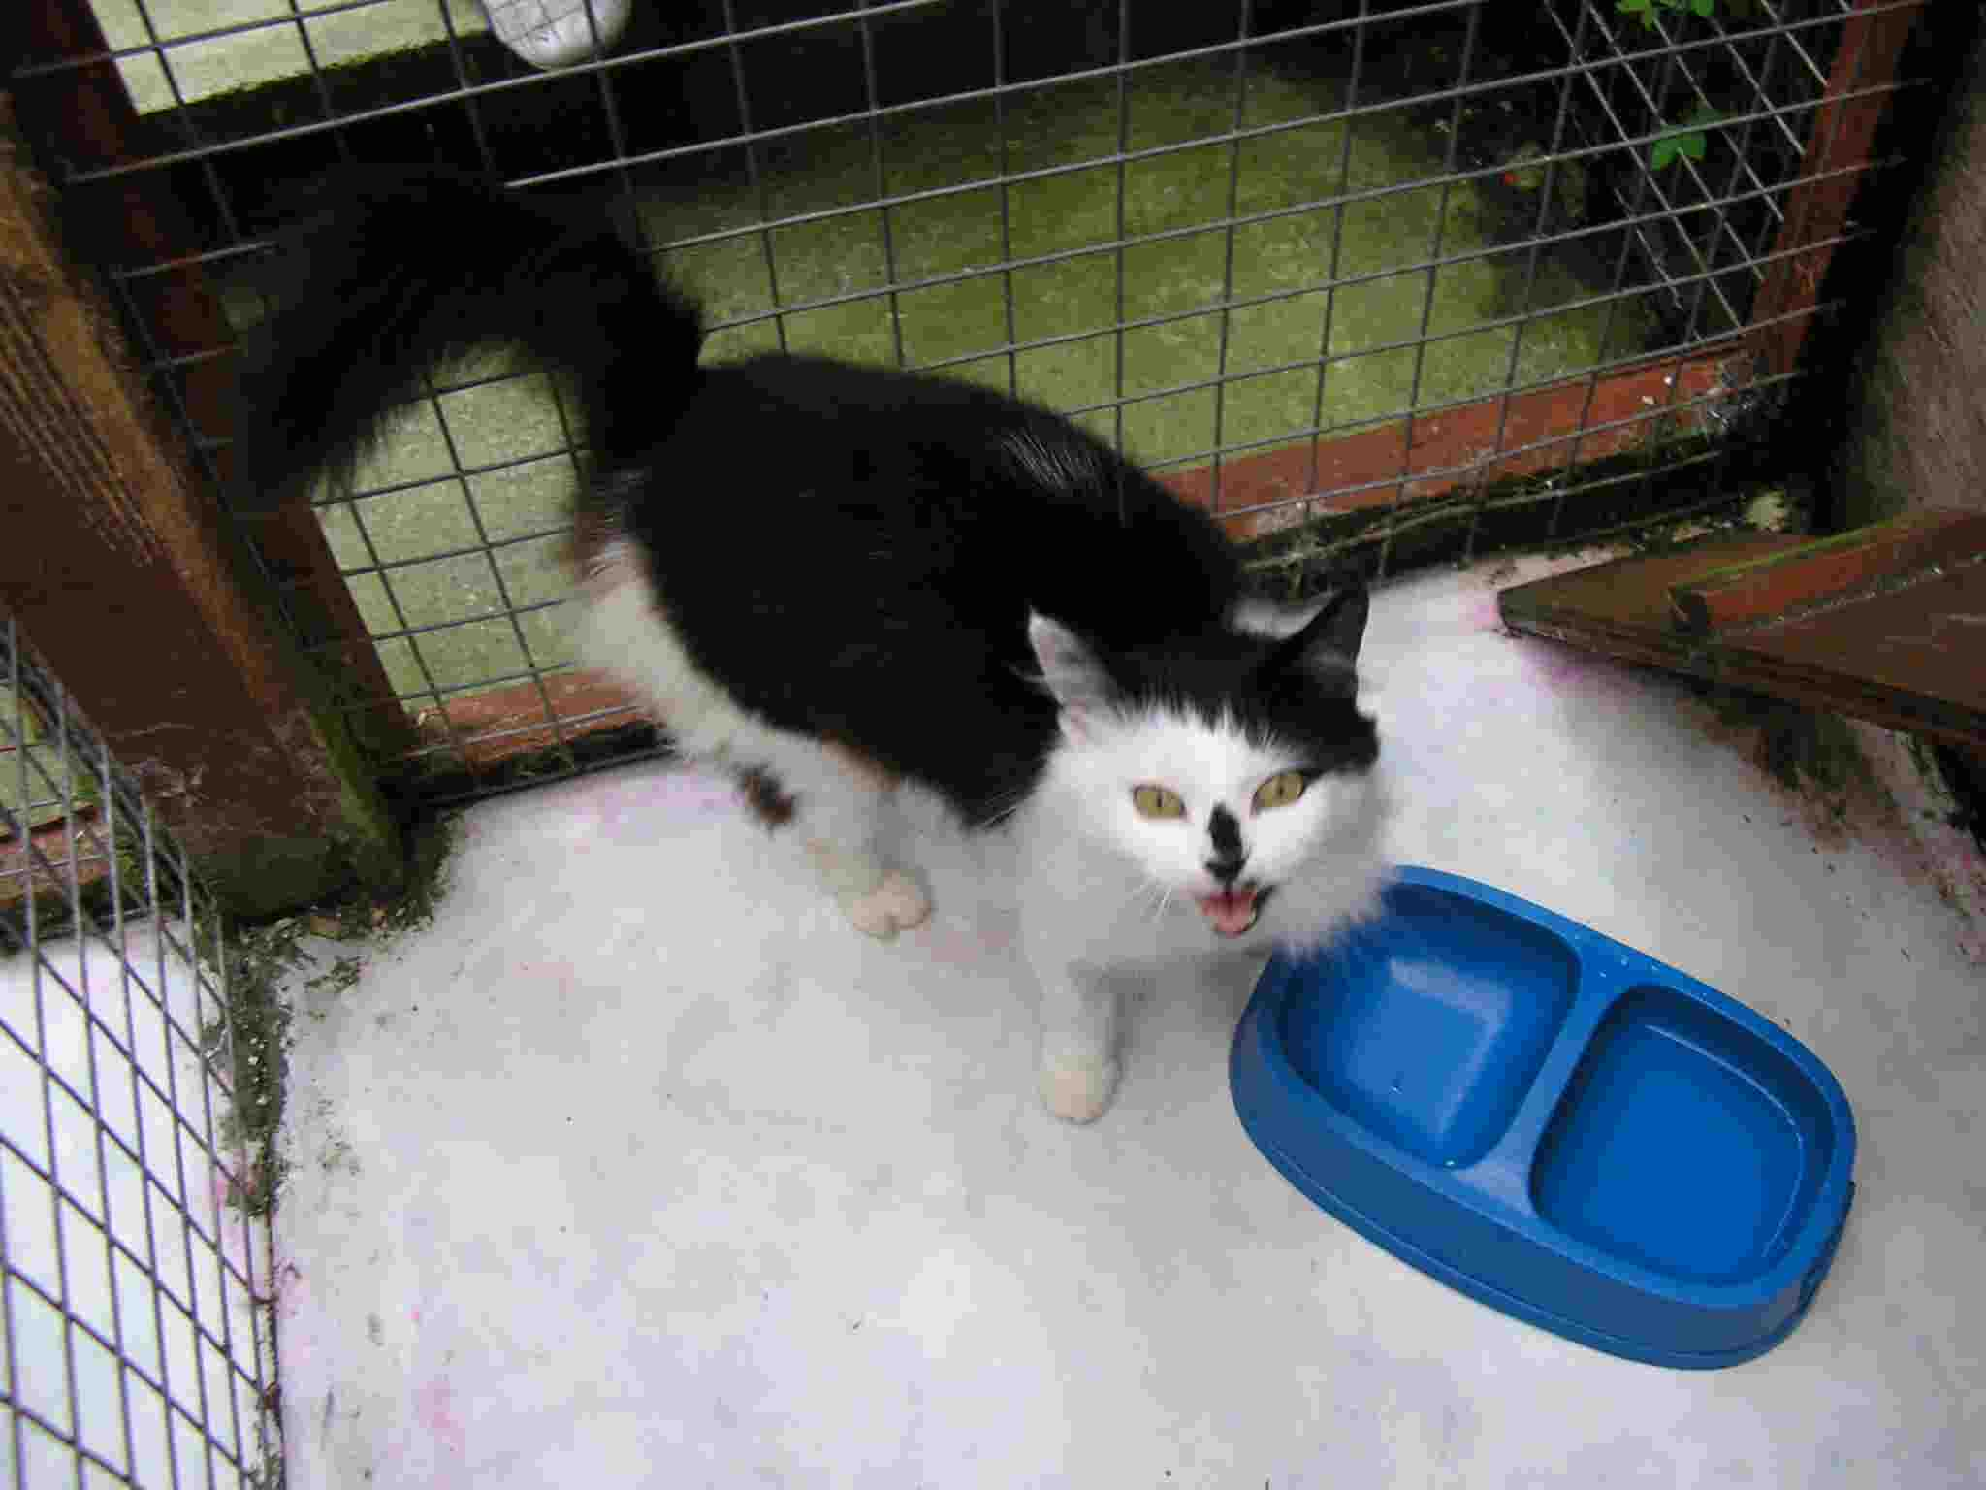

Cosmic is a very playful and affectionate black & white neutered female. She is aged 1/2. She is looking for a new home where she will get lots of love and attention.

Lottery Winners
June 06
1st – Pat Jenkins (8)
2nd - Jean Paradis (11)
July 06
1^{st -} Mrs Preston (39)
2^{nd -} Craig Johnson (17)

The lottery has proved to be a successful way of raising funds for the branch, but we would love to have more of you in the draw. It’s only £4 a month, and the September 1st prize is £100 !!
An application form is on our website or available from the branch.

MissionFish for Charities
MissionFish and eBay have teamed up to create the eBay for Charity programme which makes it easy for charities to benefit from buying and selling on eBay.
As eBay's dedicated solution provider, MissionFish, itself a charity, verifies charities, collects and disburses donations and Gift Aid (where applicable), and provides charities and donors with online donation tracking and support.
The branch have recently signed up to MissionFish, it means as a registered charity, people who use ebay have the opportunity to donate directly to the branch through ebay. If you are an ebay user then you can access the charities that are registered through the ebay site.

Brownies
A big Thank You to the 1st Knaresborough Brownie Pack for raising £50 by bringing copper along to their meeting and donating it to the Branch.

Sponsored Silence
A big Thank You also to Katie Bruce and Amelia Lucking for donating £47.50 to the Branch from a sponsored silence at Spofforth School.
We really do appreciate the efforts of our younger supporters.

Microchipping
The Branch desperately needs someone who can microchip on behalf of the Branch at events and when necessary. It would be great to hold a local microchipping day once or twice a year, it would not only raise the branch profile but hopefully would encourage more owners to have their animals microchipped. If you are interested in finding out more then please contact me.

Menwith Hill – Responsible Pet Ownership Event Thursday 26th October
We have been asked by Menwith Hill to participate in the above event. I will be going along to chat about the importance of microchipping, neutering etc to several different groups on that day.
We have also been asked if we can microchip dogs and cats on that day as the Americans do not have access to microchipping on the base.
If you are interested please let me know in advance and we can organise microchipping training for you.

Neutering Campaign
Following on from our successful neutering campaign earlier in the year we are now looking to hold another campaign October/November time.

Jumble Sale
We are hoping to hold a jumble sale at Hampsthwaite in October/November so please start keeping any jumble. I will confirm the date as soon as possible.

Mutt Strutt – Sunday 15th October
Following from last year’s successful Mutt Strutt we will be holding it again on Sunday 15th October around Ripley Castle at 11.00am
The route is approx. 3 miles and is very easy going.
There will be prizes on offer for different categories and a pet tombola.
Refreshments will be available at the start and end of the walk.
Entry is £5 per family or by sponsorship form.
Registration forms are available by contacting the branch, and entries are now being taken.
We will need some volunteers to help on the day with refreshments, registration etc
Please do come along and support this event, we had such fun last year and raised funds for the branch in the process.

Pets Photograph Competition
The winner was Amber owned by Donna Lambert of Knaresborough.
Amber is featured here as Pet of the Month for August.

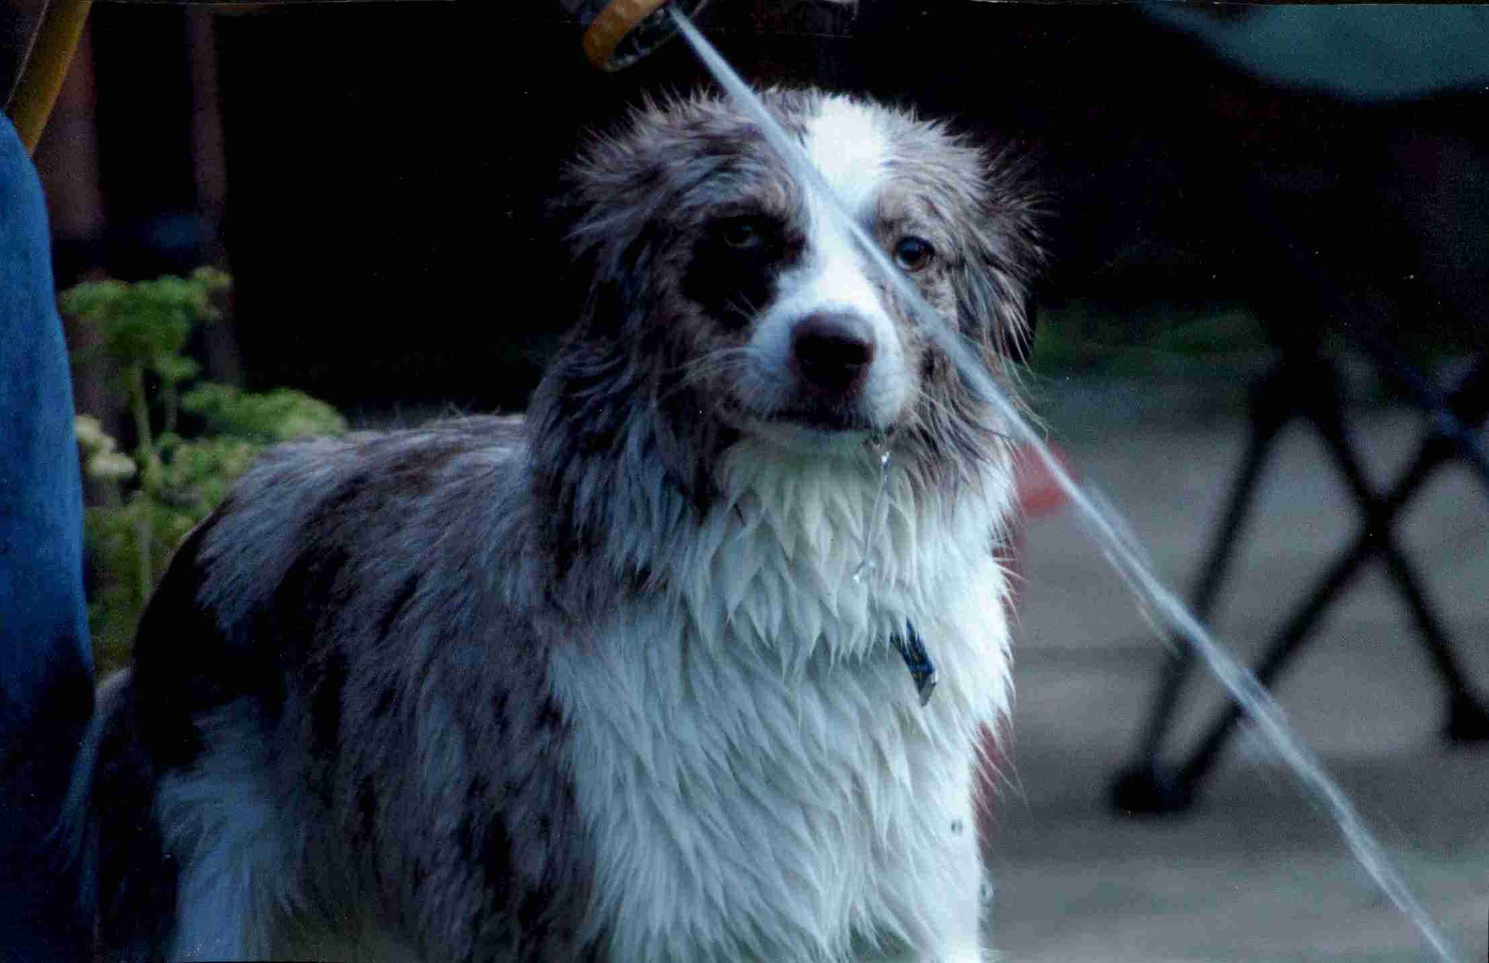

2nd Prize went to Harry owned by Pat Jenkins of Collingham.
Harry is featured here as Pet of the Month for September.

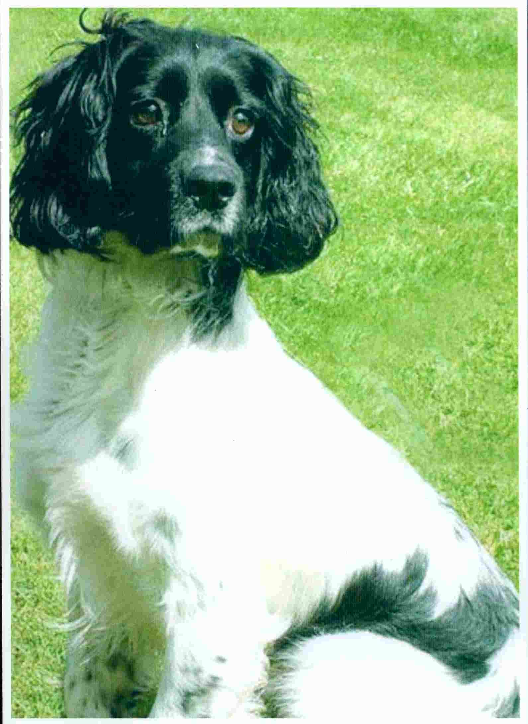

3rd Prize went to Sherpurr owned by Mrs P Ricci of Harrogate. Sherpurr will be featured in our next newsletter as Pet of the Month.

Thank you to everyone who took part in the competition.

Shop Update
We have looked at several properties recently in Knaresborough but unfortunately to date none have been suitable.
Please let me know if you spot anything that comes up for let in Knaresborough. I do make a weekly trip just to check but if something does become available then we need to be able to view quickly.

Supermarket Collections
We do need help with upcoming supermarket collections, if you can spare an hour please do let me know.
Sainsbury’s Harrogate Saturday 16th Spetember (If you can volunteer an hour for this collection please can you let me know before Thursday 7th September)
As I will be on holiday I have arranged for someone to be there with the tins early morning. We need helpers from 10.30am onwards. Whoever does last slot will be able to leave the tins with Gemma my daughter as she will be working in Sainsbury’s on that day.
Morrsions Boroughbridge Saturday 23rd September
Collectors needed, if you can let me know beforehand if you can spare an hour.

EVENTS 2006

Sainsbury’s Harrogate Collection – Saturday 16th September

Trustee Meeting – Thursday 21st September @ 7.30pm @ The Kestrel

Morrisons Boroughbridge Collection – Saturday 23rd September

Friends Meeting – Thursday 5th October @ 7.30pm @ The Kestrel

Mutt Strutt – Sunday 15th October @ 11.00am

AGM – Monday 30th October @ 7.30pm @ The Kestrel

Jumble Sale @ Hampsthwaite – October/November date to be confirmed

Morrisons Starbeck Collection – Saturday 18th November

Wetherby Xmas Fayre – Saturday 18th November

Xmas Meal – December (Date/venue to be decided)

