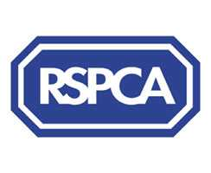

Harrogate & District Branch Newsletter
Registered Charity No. 232219

September 2011
www.rspcaharrogate.org.uk

BRANCH CONTACT DETAILS

Branch Manager – Jill Johnson
PO Box 608
Harrogate
HG1 9EY
01423 886249

To report an animal in distress or an emergency,
please contact the RSPCA 24-hour Cruelty and Advice line
0300 1234 999

Stray Dogs
Neither the RSPCA nor the police can deal with stray dogs, which are the responsibility of the Dog Warden Service. The numbers to ring about strays are now:

If you find a dog
Please ring 01423 556633 or 01423 500600 during office hours
or 07525 988048 for the Out of hours stray dog reception.

If you have lost a dog
Please ring 01423 556633 or 01423 500600 during office hours or
07525 988048 for the Out of hours stray dog reception.

BRANCH & ANIMAL UPDATES

Microchipping Campaign
The Branch microchipping campaign will take place from 1st October to 31st October 2011. For just £12.50 you can have your dog or cat microchipped at the following veterinary surgeries.
Vets4Pets Harrogate 01423 886666
Hutchinson Dunlop & Baird Wetherby 01937582025
Westwood Vets Boston Spa 01937 842210
Bishopton Vets Ripon 01765 602396
Rae Bean & Partners Boroughbridge 01423 322316

Birstwith Show was a huge success with well over 100 entries for the dog classes. We changed a number of classes this year to make it more fun for owners and dogs and they went down very well. Musical sit is now a firm favourite! The organisers had moved us to a much more central position this year and I think that certainly helped. It was a beautiful sunny day and everyone had a lovely time.

Bupa Southlands held their annual dog show and afternoon tea event for us in June. Although there were few dog show entries a great afternoon was had by all and over £400 was raised. A big Thank You to Bupa for hosting the event in aid of the Branch.

Lottery Winners
March – 1st Sue Wilson (64)
2nd Ruth Greenwood (41)
April - 1st Peter Bolton (23)
2nd Freda Jefferson (58)
May - 1st Pat Jenkins (8)
2nd Vicky Crawley (20)
June - 1st Charlotte Davison (66)
2nd Stella Brown (50)

To join our exclusive ‘Waifs & Strays’ Lottery 100 Club, all you have to do is pay a £1 membership fee and complete the attached form agreeing to pay £4 per month by standing order. This will enter you in our very own ‘Waifs & Strays’ Lottery.

Each month for 10 months one lucky member of the ‘Waifs & Strays’ Lottery will win £50 and a second member will win £20. In addition twice a year, in March and September there will be a Mega Prize Draw where the first prize will increase to £100 and the second prize to £40. The draw will take place on the last day of every month.

You stand a very good chance of winning any one of the 24 prizes, and you will be helping the local branch of the RSPCA at the same time.

Animal Updates
We have been very busy trying to find new homes for cats and kittens. Rusty shown below came in with his 2 brothers and sister. Mum also came in with them but decided to reject them so I took them all home for a few weeks as they were so small. Luckily they all thrived and ended up absolutely bomb proof as I was having the house roof replaced and it did not bother them one little bit…..All have now been rehomed.

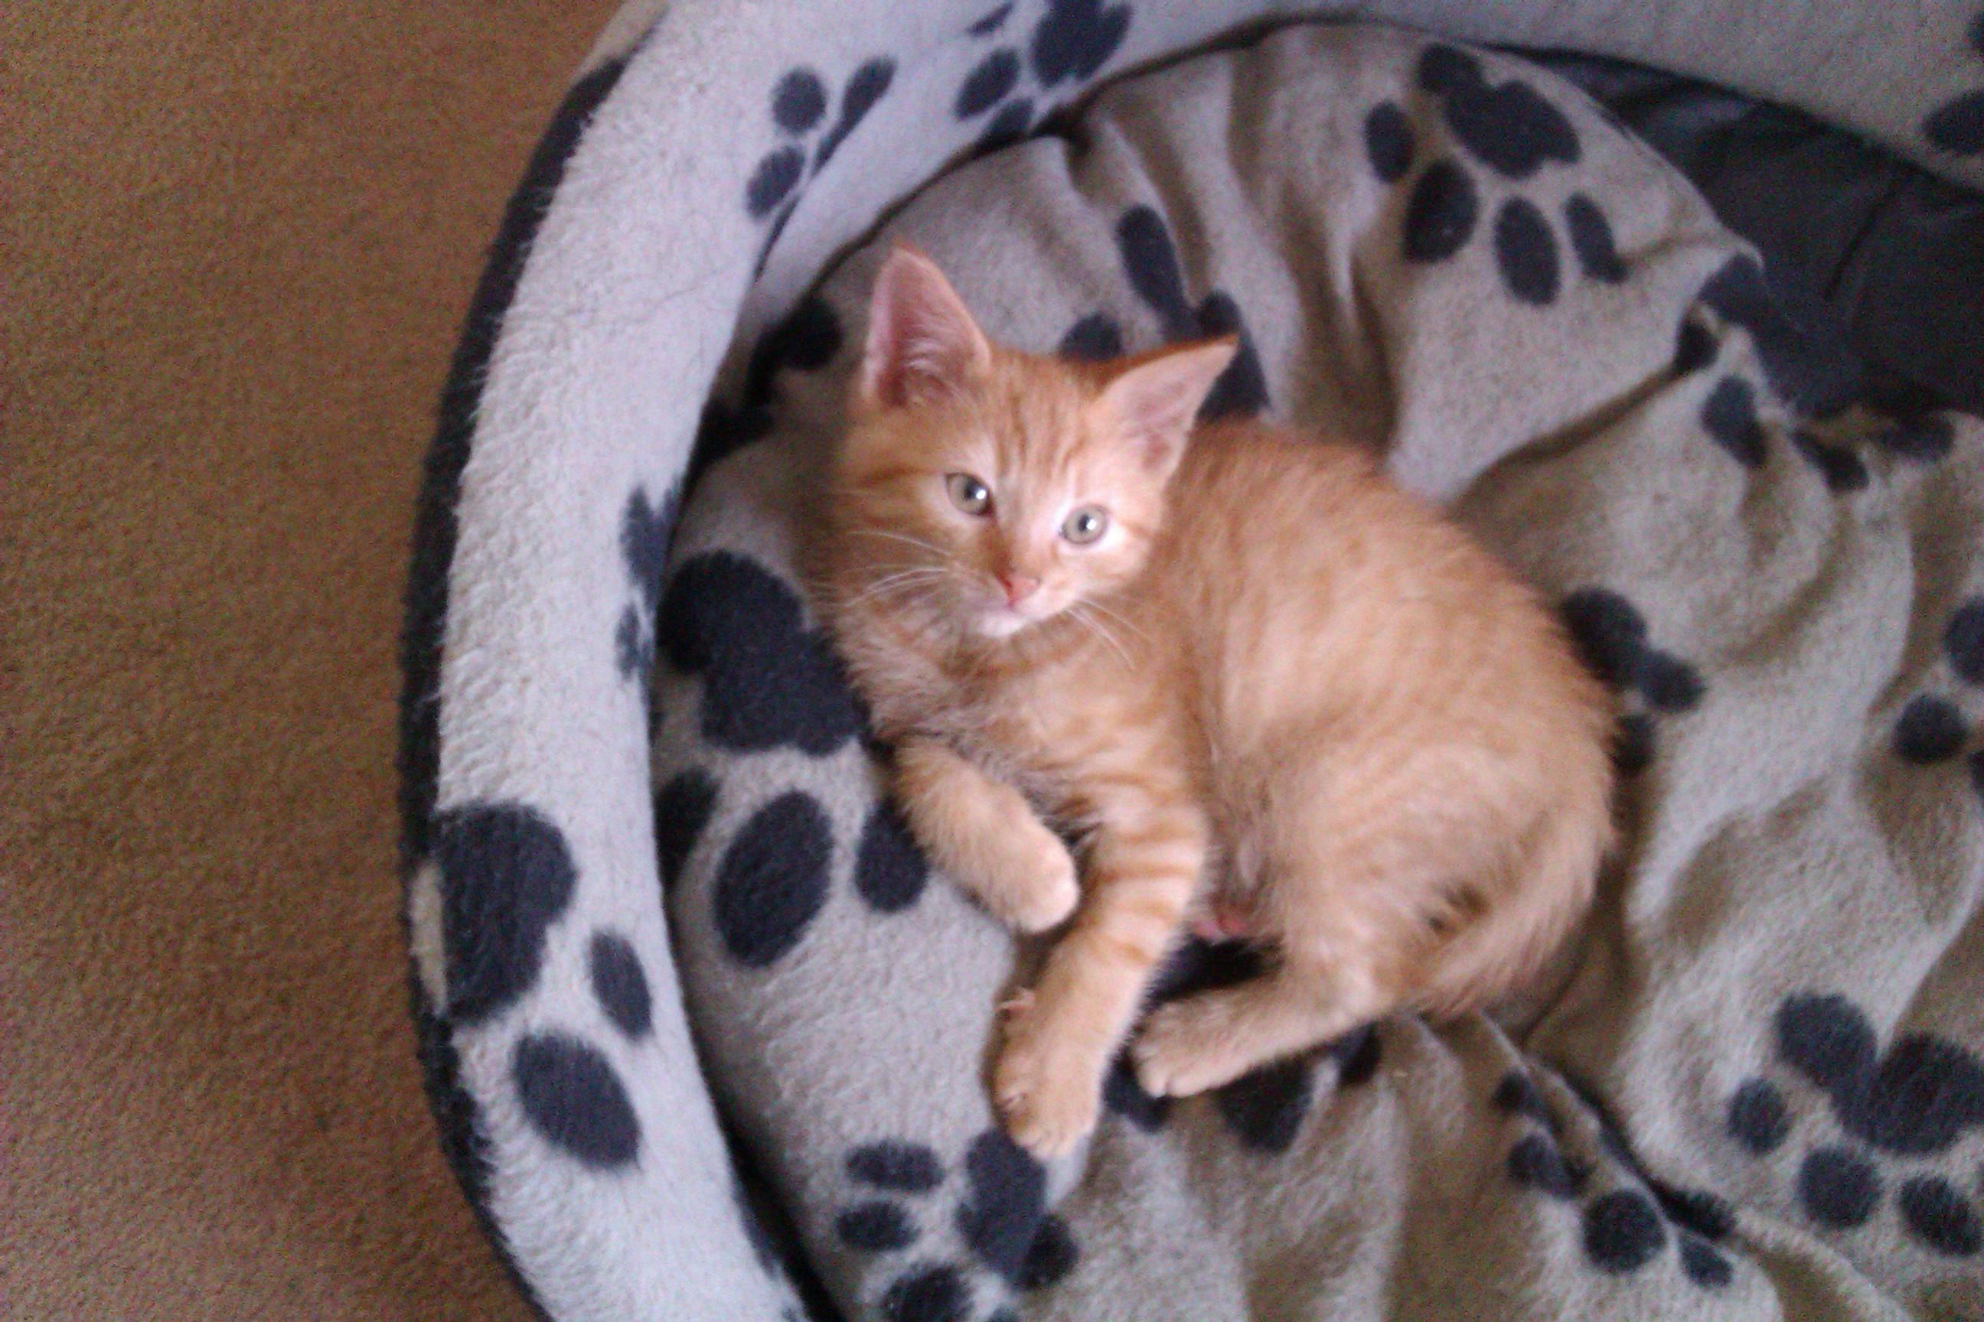

Elmo, Figaro and Dolly are three lovely kittens who will be ready to go to new homes in a couple of weeks. They were found abandoned in a cardboard box, they are all very friendly and full of fun.

Toby black neutered male aged about 3, Toby is very quiet and looking for a loving home with no young children or other pets. Toby has lots of love to give to someone who is prepared to give him time and affection.

Topsy black neutered female aged about 1. Topsy is a lovely young cat who is very playful and affectionate.

Vets4Pets have a brilliant offer on Vaccinations for life at only £49 for dogs & cats. The Vac4Life plan gives free annual booster vaccinations and annual health checks for life for just £49. This offer only applies to NEW clients.

Best Start in Life is another offer for puppies and kittens. For just £55
Primary Vaccination Course (2 injections)
Initial flea & worm treatment
Microchip
Bag of Royal Canin Food
10% discount on neutering
Discount voucher book for Royal Canin Food
Plus 4 weeks insurance with Cover4Pets.
This offer also only applies to New clients.

If you want to take advantage of either of the above offers please contact Jill on 01423 88629 to get your vouchers. For every voucher used the Branch gets a donation from Vets4Pets Harrogate. Offers apply until 31st October.

Forthcoming events
Collection at Morrisons Harrogate on Friday 23rd September (still need additional collectors)
Collection at Sainsbury’s Harrogate on Friday 28th October (still need additional collectors)

Xmas Fayre
Thursday 3rd November Brearton Village Hall @ 7pm – 9pm
£1 entry with free glass of wine.
Jewellery, homewares, childrens gifts, paintings, menswear and womenswear.
Tombola
Proceeds towards RSPCA Harrogate & District.
Please come along and do some Xmas shopping.

Quiz & Curry Night
Tuesday 29th November, Smiths Arms Beckwithshaw @ 7.30pm
£5 for quiz & curry
Raffle
Ring Charlie on 07940 469085 or Jill on 01423 886249 to reserve tickets.

Trustees and Volunteers - Can you help?
Volunteers are the life-blood of any charity, and you can help in many different ways, giving yourself new experiences, putting your skills and interests to use, and meeting new people.
Just some of the roles we need volunteers for are: photographing animals for rehoming, helping in our shops, fundraising, and home-visiting people who would like to adopt.
Trustees are at the heart of every charitable organisation. Our branch trustees have ultimate responsibility for the branch and must act in the best interests of the charity. We have vacancies for trustees at the moment and would like to hear from anybody with interest and time to spare who would like to find out more about this commitment.
Call us on 01423 886249 or use the form on the next page if you would like to find out more

Please send your comments and donations to:
RSPCA, Harrogate & District PO Box 608 Harrogate HG1 9EY
Registered Charity Number 232219.
Please remember to always quote all this information when making out donations or a legacy.
See our leaflet about leaving money to help animals in Harrogate & District.

Donor’s Details
Full Name: ________________________________________________________
Home Address: ________________________________________________________

________________________________________________________

________________________________________________________

Postcode: ________________________

Phone number: _______________________

Yes / No – I am interested in volunteering – please contact me

Donation (if applicable) Amount £____________________

Let us know if you already give a regular donation to RSPCA HQ and you wish us to benefit from it.
N.B. Please sign and date your form:
Yes / No - I am a UK Taxpayer and I wish to Gift Aid any donations I have made or make to the RSPCA Harrogate & District Branch

Signed_________________________

Date__________________________

Remember: Full name + Home address + Postcode + Sign =
You can make your donation worth 25% more to us, at no extra cost to you, simply by making the Gift Aid

Notes: - 1 - You must pay an amount of income tax or capital gains tax at least equal to the tax the charity reclaims - currently 25p for each £1 you give.
2 - If your circumstances change, you can cancel this declaration by notifying the Charity. 3 - If you pay a higher rate of tax, you can claim further relief in your Self Assessment Tax Return.

OVER TO YOU

We would love to include your stories and experiences in our newsletter.

Have you adopted a rescue animal?

Have you organised and event and would like to tell us about it?

Do you have a pet with attitude who would love to have their photo in print?

Please send your contributions via email or by post to have them included in the next edition of the Branch newsletter.

