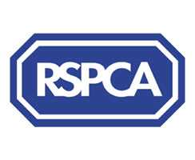
HARROGATE & DISTRICT BRANCH

Registered Charity 232219

PETS PHOTO COMPETITION

Entry Fee: £1.00 per picture

Closing Date: 10th August 2012

Categories: Best Dog
Best Cat
Best other animal
Best Wildlife in their habitat
Best animal picture taken by a child under 12yrs
Prizes for winner of each category and rosettes for 1st, 2nd and 3rd in each category

ENTRY FORM

Name:……………………………………………………….Telephone No:……………………………………….

Address:………………………………………………………………………………………………………………………

……………………………………………………………………Post Code:………………………………………………

No. of Photographs enclosed:……………..Entry Fee Enclosed:…………………………….

Cheques made payable to RSPCA Harrogate

Please put your name, address and pets name on the back of each photograph or for the wildlife picture please write the animal type.
Photographs should be no bigger than 7” by 5” and taken by an amateur photographer.
Photographs will be returned at the end of the competition providing a large stamp addressed envelope is included with the entry form.
All funds raised from this competition will benefit the local Harrogate & District Branch of the RSPCA.

Entries to : RSPCA Harrogate & District Fundraising, PO Box 182, Knaresborough, HG5 5BB
Tel: 07817 344139 www.rspcaharrogate.org.uk or find us on Facebook

Thank you for your support

