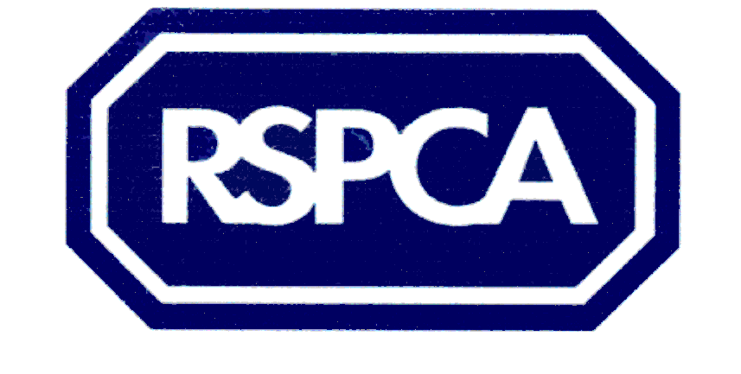
Harrogate & District Branch
Voucher Scheme

The RSPCA is a charity and does not receive any help from the Government or the local authority. All the money we spend has to be raised by hard working volunteers, who give their time to fundraise to help local animals.

If you are unable to afford private veterinary treatment and are in receipt of Income Support, Housing benefit or Council Tax benefit, we may be able to help you.

Please provide the information requested below.

Your name: (IN CAPITALS) …………………………………………………………………

Your address: (IN CAPITALS) …………………………………………………………….
…………………………………………………………………………………………………

Postcode:………………………………… Tel no: …………………………………………..

Which of the above benefits are you in receipt of?

………………………………………………………………………………………………….
PLEASE ATTACH PHOTOCOPY OF RELEVANT & CURRENT BENEFIT BOOK.

Animal's details:
Type (i.e. cat/dog, breed, size): …………………………………………………………………………………………………..Age: ……………………….. ……………...Sex: ……………………………………………
Colour/markings: ………………………………………………………………………
Nature of animal's complaint: ………………………………………………………………..

What is the estimated cost of the treatment? ……………………………………………...
PLEASE ASK YOUR VET ABOUT THIS.

Name & address of your veterinary practice: ……………………………………………………………………………………………………..………………………………………………………………………………………………
If you really need help, please sign and post the form to the address below. If the application is approved, a voucher will be issued and sent to your vet.

Please read the following before signing.
I am the owner of the animal to be treated. The statement I have made is, to the best of my knowledge, true. If untrue, I may be breaking the law.

Signed: ………………………………………………………………………………………...
IMPORTANT: If you are willing to help us raise funds to maintain this service, please tick the box:

Please post the signed, completed form to
Jill Johnson, RSPCA, PO Box 608 Harrogate HG1 9EY

Registered charity no: 232219

